

THE UNITED REPUBLIC OF TANZANIA




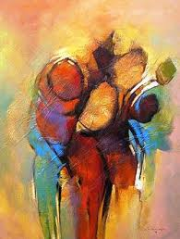
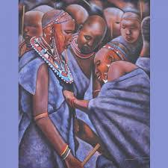

MINISTRY OF INFORMATION, CULTURE, ARTS AND SPORTS

INFORMATION, CULTURE, ARTS AND SPORTS
STATISTICS REPORT, 2016
TANZANIA MAINLAND
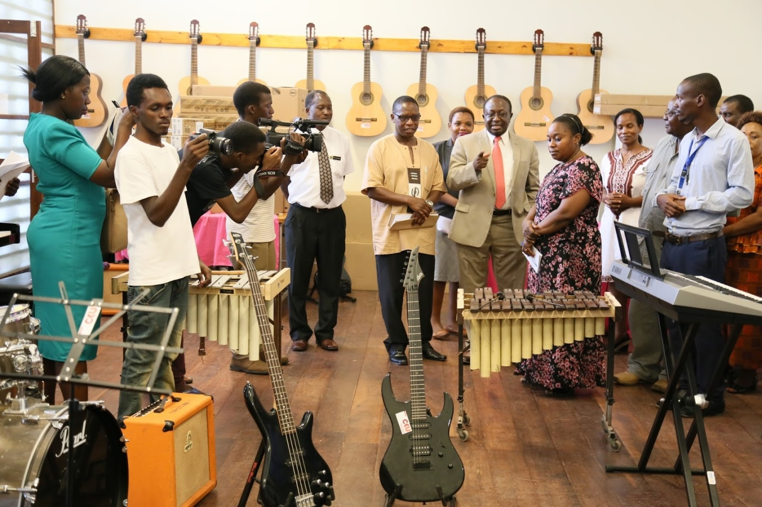
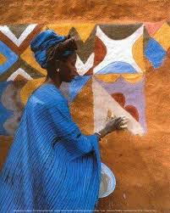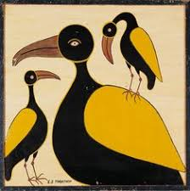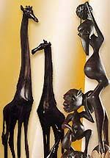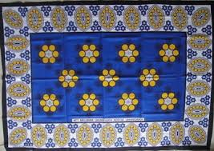

March, 2019

TABLE OF CONTENTS
LIST OF TABLES v
LIST OF FIGURES viii
ABBREVIATIONS x
CHAPTER ONE 1
INTRODUCTION 1
CHAPTER TWO 2
METHODOLOGY 2
2.1 Data Sources 2
2.2 Data Processing 3
2.3 Scope and Coverage 3
2.4 Data Sustainability 3
2.5 Periodicity 3
CHAPTER THREE 4
SECTORAL STATISTICS 4
3.1 Information Sector Statistics 4
3.1.1 Registered Television Stations 4
3.1.2 Registered Radio Stations 6
3.1.3 Press Cards Issued 11
3.1.4 Registered Magazines 12
3.1.5 Registered Kiswahili and English Newspapers 13
3.1.6 Warned Newspapers 14
3.1.7 Banned Newspapers 14
3.1.8 Sales of Newspapers by TSN 15
3.1.9 Tanzania Broadcasting Corporation (TBC) 17
3.1.9.1 TBC Radio Coverage 17
3.1.9.2 Television Coverage in Tanzania Mainland 19
3.1.9.3 List of Districts not covered by TBC Radio Frequency by 2016 20
3.2 Culture Statistics 22
3.2.1 African Liberation Heritage sites in Tanzania 22
3.2.2 Services Offered by BAKITA 23
3.3 Arts Statistics 25
3.3.1 Cultural Groups Participation at Bagamoyo Arts and Cultural Festival 26
3.3.2 Diploma Students Enrolled and Graduated at TaSUBa 26
3.3.3 Audience at the Bagamoyo Arts and Cultural Festival 28
3.3.4 Number of Graduates in Short Courses 29
3.3.5 Theatre/Drama and Music Groups Registered 31
3.3.6 Individual Artists Registered 32
3.3.7 Licensed Cultural Events 33
3.3.8 Permits issued to Foreign Artists who Performed in Tanzania 34
3.3.9 Number of Permits issued to Local Artists Performed Outside the Country 34
3.3.9.1 Foreign Artists Performing in the country 35
3.3.9.2 Local Artists who performed Outside the Country from 2011 to 2016 36
3.3.9.3 Local and International Awards (Trophies) Won by Local Artists 37
3.3.9.4 Banned Music (songs) From 2011/12 to 2015/16 37
3.3.9.5 Registered Arts Promoters and Associations from 2012 – 2016 38
3.3.9.6 Film and Stage Plays Industry 39
3.3.9.6.1 Filming Permits 39
3.3.9.6.2 Classified and Certified Films 41
3.3.9.6.3 Illegal Film Products Confiscated 42
3.3.9.6.4 Tax Stamps for Film and Music Products 43
3.3.9.6.5 Banned Films 44
3.3.9.6.6 Film Awards 44
3.4 Sports Statistics 45
3.4.1 Enrolment at Malya College of Sports Development 45
3.4.2 Sports Bodies Registration 46
3.4.3 Travel Permits issued by NSC 48
3.4.4 Association/Federation Elections Conducted by NSC 49
3.5 Human Resources Performance Indicators and Budget 50
3.5.1 Human Resource Distribution by Departments/Units 50
3.5.2 Distribution of Staff by Level of Education 52
3.5.3 Short and Long Courses 52
3.6 Human Resources Performance Indicators and Budget 53
3.6.1 Human Resource Distribution by Departments/Units 53
3.6.2 Distribution of Staff by Level of Education 55
3.6.3 Short and Long Courses 55
3.7 Budget Overview 56
3.7.1 Budget Trend 56
3.7.2 Approved Budget for Financial Year 2015/16 and 2016/17 57
3.7.3 Budget Allocation for the Ministry and Institutions (Other Charges) 58
3.7.4 Planned and Actual Revenue 59
3.8 Conclusion and Recommendations 61

LIST OF TABLES
Table 3.1: List of Registered Television Stations in Tanzania Mainland from 2005 – 2016. 5
Table 3.2: List of Registered Radio Stations in Tanzania Mainland 7
from 2005 - 2016 7
Table 3.3: Registered Radio and TV Stations, Tanzania Mainland, 2012 - 2016 10
Table 3.4: Number of Journalist Media Accreditation Cards (Press Cards) Issued, Tanzania Mainland, 2012 - 2016 12
Table 3.5 Number and Percentage Change of Registered Magazines, Tanzania Mainland, 2012 – 2016 13
Table 3.6: Number of Registered Kiswahili and English Language Newspapers, Tanzania Mainland, 2012 – 2016 14
Table 3.7: Number of Warned Newspapers, Tanzania Mainland, 2012 – 2016.. 14
Table 3.8: Number of Banned Newspapers, Tanzania Mainland, 2012 - 2016 15
Table 3.9: Number of Newspaper (Daily News, Habari Leo and Sports Leo) allocated, returned and sold from 2012 – 2016 by TSN 16
Table 3.10: List of Districts covered by TBC radio (TBC Taifa, TBC FM and TBC-International) and their frequencies, Tanzania Mainland 2012-2016 18
Table 3.11: Distribution of Regions Covered with Digital Platform, Tanzania Mainland 2010 - 2016 20
Table 3.12: List of Districts not covered by TBC Radio Frequency 21
Table 3.13: African Liberation Heritage Sites by Regions, Tanzania Mainland, 2016 23
Table 3.14: Number of Services Provided 2010 to 2016 24
Table 3.15: Number of Local and Foreign Cultural Groups Participation at the Bagamoyo Arts and Cultural Festival, Tanzania Mainland, 2012 – 2016 26
Table 3.16: Number and Percentage of Diploma Students Enrolled at TaSUBa by Sex, Tanzania Mainland, 2012 - 2016 27
Table 3.17: Number and Percentage of Diploma Graduates From TaSUBa, Tanzania Mainland, 2012 - 2016 27
Table 3.18: Audience at Bagamoyo Arts and Cultural Festival 28
Table 3.19: Number of Graduates at TaSUBa by Course and Sex, Tanzania Mainland, 2013-2016 30
Table 3.20: Number of Registered Theatre/Drama and Music groups by Region, Tanzania Mainland from 2010 to 2016 32
Table 3.21: Registered Individual Artists of Films, Crafts, Performing Arts and Music, Tanzania Mainland, 2012 - 2016 33
Table 3.22: Number of Licensed Cultural Events, Tanzania Mainland, 2011/2012- 2015/2016 33
Table 3.23: Permits issued to Foreign Artists, Tanzania Mainland, 2012 – 2016 34
Table 3.24: Permits issued to Local Artists Performing Outside the Country, Tanzania Mainland, 2012 – 2016 35
Table 3.25: Foreign Artists who Performed Within the Country from 2012 – 2016 35
Table 3.26: Local Artists who Performed Outside the Country (2011 – 2016) 36
Table 3.27: Local and International Awards (Trophies) Won by Local Artists Tanzania Mainland, 2011/12 – 2015/16 37
Table 3:28: Registered Arts Promoters and Associations from 2012 – 2016 39
Table 3.29: Filming Permits Issued by Type, Tanzania Mainland, 2011/12 - 2015/16 40
Table 3.30: Classified and Certified Films by Category, Tanzania Mainland, 2011/12 - 2015/16 42
Table 3.31: Illegal Film Products Confiscated, Tanzania Mainland, 2013/14 – 2015/16 43
Table 3.32: Tax Stamps by Type, Tanzania Mainland, 2013/14 - 2015/16 43
Table 3.33: Banned Films by Type, Tanzania Mainland, 2011/12 - 2015/16 44
Table 3.34: Local and International Film Awards , Tanzania Mainland, 2012 – 2016 44
Table 3.35: Students Enrolled at Malya College of Sports Development by Sex, Tanzania Mainland, 2012-2016 45
Table 3.36: Graduates from Malya College of Sports Development, Tanzania Mainland, 2012 - 2016 46
Table 3.37: Registered Sports Clubs, Associations and Academies, Tanzania Mainland,2012 – 2016 46
Table 3.38: Distribution of Registered Sports Clubs, Sports Associations and Sports Academies by Region, 2016 48
Table 3.39: Distribution of Employees by Department and Sex, by 2016 54
Table 3.40: Number of Employees by Level of Education and Sex, Tanzania Mainland, 2015/16 55
Table 3.41: Employees who Attended Long and Short Term Courses, Tanzania Mainland, 2011/12 – 2015/16 56
Table 3.42: Budget (TZS million) Allocation for MICAS, Tanzania Mainland, 2011/12 – 2015/16 57
Table 3.43: Recurrent Budget (TZS million) for MICAS by Department/Unit, Tanzania Mainland, 2015/16 and 2016/17 58
Table 3.44: Planned Budget (TZS millions) of OC for MICAS and Institutions, Tanzania Mainland, 2011/12 - 2015/16 ………………. 56
Table 3.45: Planned and Actual Revenue - MICAS (TZS millions), Tanzania Mainland, 2011/12 - 2015/16…………………………………….…..56

LIST OF FIGURES
Figure 3.1: Registered Radio and Television Stations, Tanzania Mainland, 2016 11
Figure 3.2: Number of Press Cards Issued to Local and Foreign Journalists, Tanzania Mainland, 2012 - 2016 12
Figure 3.3: The percentage of Sales of Newspapers (Daily News, Habari Leo and Sports Leo) from 2012 to 2016 16
Figure 3.4: Number of Mistakes of Kiswahili Language in Media, Tanzania Mainland, 2010 to 2016 25
Figure 3.5: Distribution of Diploma Graduates From TaSUBa, Tanzania Mainland, and 2012 - 2016 28
Figure 3.6: Percentage of Male and female Audience at Bagamoyo Arts and Cultural Festival from 2015 to 2016 29
Figure 3.7: Number of Graduates at TaSUBa, Tanzania Mainland, 2013 – 2016 30
Figure 3.8: Licensed Cultural Events from 2011/12 - 2015/16. 34
Figure 3.9: Distribution of Foreign Artists who Performed within the country from 2012 – 2016 36
Figure 3.10: Banned Local Music (songs), 2014/15 and 2015/2016 37
Figure 3.11: Registered Arts Promoters and Associations, 2012 – 2016 39
Figure 3.12: Local and Foreign Filming Permits, Tanzania Mainland, 2011/12 – 2015/16 41
Figure 3.13: Classified and Certified Films by Category, Tanzania Mainland, 2011/12 – 2015/16 42
Figure 3.14: Travel Permits issued by NSC, Tanzania Mainland, 2015 and 2016 48
Figure 3.15: Association/Federation Elections Conducted in Tanzania Mainland, 2015 and 2016 49
Figure 3.16: Percentage Distribution of Employees by Sex, Tanzania Mainland, 2015/16 54
Figure 3.17: Percentage of Revenue Collection – MICAS , Tanzania Mainland, 2011/12 to 2015/16 60

ABBREVIATIONS
ATN | Agape Television Network
BAKITA | Baraza la Kiswahili la Taifa
BASATA | Baraza la Sanaa la Taifa
BMT | Baraza la Michezo la Taifa
CCM | Chama cha Mapinduzi
DTV | Dar es Salaam Television
EATV | East Africa Television
MICAS | Ministry of Information, Culture, Arts and Sports
NACTE | National Council for Technical Education
NBS | National Bureau of Statistics
NSC | National Sports Council
OC | Other Charges
RFA | Radio Free Africa
SUATV | Sokoine University of Agriculture Television
TaSUBa | Taasisi ya Sanaa na Utamaduni Bagamoyo
TBC | Tanzania Broadcasting Corporation
TCRA | Tanzania Communications Regulatory Authority
TFB | Tanzania Film Board
TRA | Tanzania Revenue Authority
TSMP | Tanzania Statistical Master Plan
TSN | Tanzania Standard Newspapers
TUKI | Taasisi ya Uchunguzi wa Kiswahili (Institute of Kiswahili Research)
TV | Television
UDSM | University of Dar es Salaam
UNESCO | United Nations Educational, Scientific and Cultural Organization
VEC | Video Exhibition Centre
AU | African Union
OAU | Organization of African Unity

FOREWORD
The second Annual Statistics Report of the Ministry of Information, Culture, Arts and Sports is prepared in order to provide stakeholders of the Ministry with important statistical information, mainly regarding the growth of the sectors under the Ministry. Unlike its preceding report, the 2016 report has included new statistical information that have been generated from the sectors and institutions under the Ministry. This is more comprehensive and in line with increased stakeholders’ needs for statistical information from the Ministry.

The preparation of this Report has been made possible following indispensable contributions made by various stakeholders. In this regard, the Ministry appreciates the invaluable contributions made by the National Bureau of Statistics (NBS) through the Tanzania Statistical Master Plan (TSMP) for funding the preparation of this report. The Ministry appreciates the contributions made by experts from the National Bureau of Statistics in preparing the report and particularly in ensuring that the report is consistent with the Statistical Report Writing Guidelines. Appreciations are also directed to experts of the Ministry (including institutions) who worked tirelessly to ensure that the report is rich with critical statistics that are in line with stakeholders needs and is produced in line with expected standards.

The Ministry would further like to thank the management and the entire team of the Bagamoyo Arts and Culture Institute (TaSUBa) for facilitating the Team of Experts to undertake the assignment of preparing the report at the Institute. This being the second report the Ministry is producing, and considering that similar reports will be produced in subsequent years, it is the expectation of the Ministry that stakeholders who have played critical role in the preparation of this report will grant similar support in the future.

Susan P. Mlawi
Permanent Secretary
CHAPTER ONE
INTRODUCTION

The Ministry of Information, Culture, Arts and Sports is responsible for formulating and overseeing the implementation of policies on information, culture, arts and sports. It is also mandated to coordinate and regulate the mass media, film and theatrical performance and promote culture, arts and sports in the country. In executing these mandates, the Ministry is required to develop strategies and plans and monitor their implementation. Statistical information is among the key aspects for developing relevant strategies and plans as well as assessing the extent of their implementation.

This report has, therefore, been prepared as an update to a similar report produced in 2015 for the Sectors under the Ministry (Information, Culture, Arts and Sports). This report has responded to gaps that were identified in the 2015 report including inclusion of critical statistics that were not in the previous report so as to meet the needs of stakeholders. This work will continue to be improved overtime and eventually the Ministry will possess refined statistics for specific and general use.
CHAPTER TWO
METHODOLOGY

This chapter covers the scope or coverage of the report, data sources, data quality, sustainability and data periodicity. Further, it describes the data collection procedures and data analysis techniques.

Data Sources
Data refer to a collection of facts or information gathered for a specific reason. Sources of data are categorized into primary and secondary. Primary data sources are those that information is obtained from the participant in a particular field and directly from respondents whereas, secondary data sources are those that information has already been collected by someone else in the form of documentation. This report uses both primary and secondary data from different sources within and sometimes outside the Ministry. However, most data used in this report are secondary data.

In addition to the established routine administrative system, the Ministry continued to collect data through published books, registers and websites, budget speeches and Ministry reports. Some data were collected quarterly, semiannually; and others annually depending on the nature of the data; but more important the Ministry continued to strengthen its data collection system so as to enable data collection to be done frequently.

Information in this report are from reliable sources including Ministry’s Departments/Units, National Arts Council (BASATA), National Kiswahili Council (BAKITA), Bagamoyo Arts and Culture Institute (TaSUBa), Malya College of Sports Development, Tanzania Film Board (TFB), Tanzania Standard News Papers (TSN), National Sports Council (NSC), Tanzania Communications Regulatory Authority (TCRA) and the Tanzania Broadcasting Corporation (TBC).

Data Processing
Data processing and analysis in this report includes editing, coding, classification, tabulation and presentation of collected data. It also involves examining what has been collected in survey (s) or experiment and making deductions and inferences. The analysis process was done after data collection exercise from different sources was completed. Microsoft Word and Excel were used for data cleaning, compilation and analysis.

Scope and Coverage
Data used in the compilation of this report covers all regions of Tanzania Mainland and are focusing on Information, Culture, Arts and Sports sectors. More importantly, this report contains data generated from sectors allied institutions. However, some data cover only some regions due to lack of information from other regions.

Data Sustainability
Data presented in this report are sustainable and will continue to be updated every year as they are routine. These include data from the Departments of Information Services; Culture Development; Arts Development, Sports Development; Administration and Human Resources; and Policy and Planning.

Periodicity
Information in this report will be updated every year. This report covered the period of five years (2012- 2016).
CHAPTER THREE

SECTORAL STATISTICS

This Chapter focuses on four Sectors; Information, Culture, Arts and Sports. The analysis takes on board additional data available from institutions under respective sectors. Also, the chapter is expounded to contain additional data other than that presented in the preceding statistical reports for 2015.

Information Sector Statistics
Access to information is a basic human right as defined in Article 18 of the Constitution of the United Republic of Tanzania, 1977 and the Universal Declaration of Human Rights (1948). In 2015, the Government introduced two Bills, namely the Media Services and Access to Information. In 2016, the Government enacted two Acts that were much more needed to facilitate access to information and regulation of the media sector in the country. The Sector covers media services including television, radio, newspapers, journals, social media, pictures, films, cartoons and billboards.

The Sector also presents available data from Information Department, TCRA, TBC and TSN. Some of these data are number of registered newspapers, radio and television stations, districts accessing TBC Radio and Television programs, newspaper circulation, sales trend of newspapers, journalist media accreditation cards (press card), newspapers/journals banned and warned due to misconduct.

Registered Television Stations
Apart from being a means of communication, the global media sector of which television is a major part employs many people in Tanzania as well as millions across the world. In addition, the success of public and commercial television as an advertising medium generates revenue which can be reinvested in even more great programming for viewers and other sectors of the economy.

Table 3.1 shows that from 2005 to 2016 there were 30 registered television stations in Tanzania Mainland. Among them, seven were Government owned, privately owned (18) and community/religion stations (5). Furthermore, of the 30 stations, 22 (73.3 percent) aired their programs from Dar-es-Salaam Region.

Table 3.1: List of Registered Television Stations in Tanzania Mainland; 2005 – 2016
SN | NAME | REGION | DISTRICT | COVERAGE | OWNERSHIP
 | TBC1 | Dar es Salaam | Kinondoni | National | Government
 | TBC2 | Dar es Salaam | Kinondoni | National | Government
 | Parliament Media Trust (Bunge TV) | Dodoma | Dodoma | National | Government
 | Star TV | Mwanza | Ilemela | National | Private
 | Independent Television (ITV) | Dar es Salaam | Kinondoni | National | Private
 | Clouds TV | Dar es Salaam | Kinondoni | National | Private
 | Channel Ten | Dar es Salaam | Ilala | National | Private
 | East Africa Television (EATV) | Dar es Salaam | Kinondoni | National | Private
 | Agape Television Network (ATN) | Dar es Salaam | Kinondoni | Regional | Religious
 | Imaan Television | Morogoro | Morogoro | Regional | Religious
 | VIASAT 1 Television | Dar es Salaam | Kinondoni | Regional | Private
 | Uhai Television | Dar es Salaam | Ilala | District | Private
 | Tanga City Council Television | Tanga | Tanga | District | Government
 | C2C Television | Dar es Salaam | Ilala | District | Private
 | Dar es Salaam Television | Dar es Salaam | Ilala | District | Private
 | Abood Television | Morogoro | Morogoro | District | Private
 | CTN Television | Dar es Salaam | Ilala | District | Private
 | Capital Television | Dar es Salaam | Kinondoni | District | Private
 | Sokoine University of Agriculture (SUATV) | Morogoro | Morogoro | District | Government
 | Tumaini Television | Dar es Salaam | Ilala | District | Religious
 | Mlimani Television | Dar es Salaam | Kinondoni | District | Government
 | Morning Star TV | Dar es Salaam | Kinondoni | District | Religious
 | Sibuka Television | Dar es Salaam | Kinondoni | District | Private
 | Dira Television | Dar es Salaam | Kinondoni | District | Private
 | Target TV | Dar es Salaam | Kinondoni | District | Private
 | Africa Kiswahili TV | Dar es Salaam | Kinondoni | District | Private
 | Tabibu Television | Dar es Salaam | Kinondoni | District | Private
 | WRM Network | Dar es Salaam | Ilala | District | Religious
 | Barmedas TV | Mwanza | Nyamagana | District | Private
 | Iringa Municipal TV | Iringa | Iringa | District | Government

Source: TCRA, 2016

Registered Radio Stations
Radio is an important means of communication since it enables people who cannot access television and read newspapers to get news and trends. Radio also provides portable entertainment and information to many people. It functions where television stations are not accessible. Radio is easily accessed than newspapers particularly in rural areas. The information that is given over the radio can be broadcasted to a larger number of listeners and provide them with current information.

Table 3.2 shows that, by December, 2016, Tanzania Mainland had 148 registered radio stations. Out of these stations, seven are owned by Central and Local Governments, communities (11), religious (39) and privately owned stations (91).

Table 3.2: List of Registered Radio Stations, Tanzania Mainland; 2005 - 2016
SN | NAME | REGION | DISTRICT | COVERAGE | OWNERSHIP
 | TBC_{Taifa} | Dar es Salaam | Kinondoni | National | Government
 | TBC_{FM} | Dar es Salaam | Kinondoni | National | Government
 | Radio One Stereo | Dar es Salaam | Kinondoni | National | Private
 | Radio Free Africa (RFA) | Mwanza | Ilemela | National | Private
 | Radio East Africa | Dar es Salaam | Kinondoni | National | Private
 | Clouds Entertainment FM Radio | Dar es Salaam | Kinondoni | National | Private
 | Passion FM | Mwanza | Nyamagana | Regional | Private
 | Radio Kissi FM | Mwanza | Ilemela | Regional | Private
 | Radio Uhuru FM | Dar es Salaam | Ilala | Regional | Private
 | Abood Radio | Morogoro | Morogoro | Regional | Private
 | Capital Radio | Dar es Salaam | Kinondoni | Regional | Private
 | Times Radio FM | Dar es Salaam | Kinondoni | Regional | Private
 | Sibuka FM Radio | Simiyu | Maswa | Regional | Private
 | Radio 5 Arusha | Arusha | Arusha | Regional | Private
 | Radio Ebony FM | Iringa | Iringa | Regional | Private
 | Radio Kili FM | Kilimanjaro | Moshi | Regional | Private
 | Country FM | Iringa | Iringa | Regional | Private
 | Magic FM Radio | Dar es Salaam | Ilala | Regional | Private
 | Sunrise FM Radio | Arusha | Arusha | Regional | Private
 | Triple “A” FM Radio | Arusha | Arusha | Regional | Private
 | Radio Kwizera | Kagera | Ngara | Regional | Private
 | Radio Tumaini | Dar es Salaam | Ilala | Regional | Religious
 | Radio Sauti ya Injili | Kilimanjaro | Moshi | Regional | Religious
 | Radio Maria | Dar es Salaam | Kinondoni | Regional | Religious
 | Radio Imaan FM | Morogoro | Morogoro | Regional | Religious
 | Safina FM Radio | Arusha | Arusha | Regional | Religious
 | Morning Star FM | Dar es Salaam | Kinondoni | Regional | Religious
 | Radio Mwangaza FM | Dodoma | Dodoma | Regional | Religious
 | Choice FM Radio | Dar es Salaam | Kinondoni | Regional | Private
 | Safari Radio | Mtwara | Mtwara | Regional | Private
 | Entertainment FM | Dar es Salaam | Kinondoni | Regional | Private
 | Radio Chemchemi | Rukwa | Sumbawanga | District | Private
 | Radio ya Wananchi Newala | Mtwara | Newala | District | Government
 | Boma Hai Radio | Kilimanjaro | Hai | District | Government
 | TBC_{International} | Dar es Salaam | Kinondoni | District | Government
 | Ulanga Radio FM | Morogoro | Ulanga | District | Private
 | Mwanza City FM | Mwanza | Nyamagana | District | Private
 | Mbeya City FM | Mbeya | Mbeya | District | Private
 | Nkasi FM Radio | Katavi | Nkasi | District | Community
 | City FM | Dar es Salaam | Ilala | District | Private
 | Radio Saut FM Stereo | Mwanza | Ilemela | District | Religious
 | Radio Faraja | Shinyanga | Shinyanga | District | Religious
 | Wapo Radio | Dar es Salaam | Temeke | District | Religious
 | Radio Ukweli | Morogoro | Morogoro | District | Religious
 | Praise Power Radio | Dar es Salaam | Kinondoni | District | Religious
 | Radio Upendo | Dar es Salaam | Ilala | District | Religious
 | Radio Tumaini International | Dar es Salaam | Ilala | District | Religious
 | Mlimani FM  Radio | Dar es Salaam | Kinondoni | District | Government
 | Radio Sauti ya Quran | Dar es Salaam | Ilala | District | Religious
 | Pangani FM Radio | Tanga | Pangani | District | Private
 | Living Water FM | Mwanza | Ilemela | District | Religious
 | Radio Uzima | Dodoma | Dodoma | District | Religious
 | Qiblatain FM Radio | Iringa | Iringa | District | Religious
 | Radio Habari Njema | Manyara | Mbulu | District | Religious
 | Radio Furaha | Iringa | Iringa | District | Religious
 | Baraka FM Radio | Mbeya | Mbeya | District | Religious
 | Nuru FM | Iringa | Iringa | District | Religoius
 | Radio Huruma | Tanga | Tanga | District | Religious
 | Radio Ushindi FM  Stereo | Mbeya | Mbeya | District | Religious
 | HHC Radio Station | Mwanza | Nyamagana | District | Religious
 | Afya Radio FM | Mwanza | Nyamagana | District | Private
 | Kwa Neema FM Radio | Mwanza | Ilemela | District | Religious
 | MUM FM Radio | Morogoro | Morogoro | District | Religious
 | Top Radio FM | Morogoro | Morogoro | District | Private
 | Ngurumo ya Upako | Arusha | Arusha | District | Religious
 | Radio Nuur Tanga | Tanga | Tanga | District | Religious
 | Overcomers FM Radio | Iringa | Iringa | District | Religious
 | Radio Habari Maalum | Arusha | Arusha | District | Religious
 | Siloam Radio FM | Morogoro | Morogoro | District | Religious
 | Maarifa Radio | Tanga | Tanga | District | Religious
 | Radio Hope | Iringa | Iringa | District | Religious
 | Radio Ihsaan FM | Tanga | Tanga | District | Religious
 | Ukombozi FM | Mwanza | Mwanza | District | Private
 | Mazingira FM Radio | Mara | Bunda | District | Private
 | Radio Joy | Kigoma | Kigoma | District | Private
 | Divine FM Radio | Shinyanga | Kahama | District | Religious
 | Chai FM Radio | Mbeya | Rungwe | District | Private
 | Utume FM | Tanga | Lushoto | District | Religious
 | New Life Radio  Network | Kilimanjaro | Hai | District | Religious
 | SUA FM | Morogoro | Morogoro | District | Government
 | Fountain Radio | Kilimanjaro | Moshi | District | Private
 | Shine FM Radio | Kilimanjaro | Moshi | District | Religious
 | Victoria FM Radio | Mara | Musoma | District | Private
 | Classic FM Radio | Dar es Salaam | Ilala | District | Private
 | C.G. FM Radio | Tabora | Tabora | District | Private
 | Moshi FM Radio | Kilimanjaro | Moshi | District | Private
 | Bomba FM Radio  Station | Mbeya | Mbeya | District | Private
 | Kahama FM Stereo | Shinyanga | Kahama | District | Private
 | Kifimbo Radio Station | Dodoma | Dodoma | District | Private
 | Generation FM Radio | Mbeya | Mbeya | District | Private
 | Hot FM Radio | Iringa | Iringa | District | Private
 | Radio Vision FM | Kagera | Bukoba | District | Private
 | Pride FM Radio | Mtwara | Mtwara | District | Private
 | Jogoo FM | Ruvuma | Songea | District | Private
 | ABM FM Radio | Dodoma | Dodoma | District | Private
 | Info Radio FM | Mtwara | Mtwara | District | Private
 | Planet FM | Morogoro | Morogoro | District | Private
 | Radio Metro FM  Stereo | Mwanza | Nyamagana | District | Private
 | Radio Best FM | Njombe | Ludewa | District | Private
 | Dodoma FM | Dodoma | Dodoma | District | Private
 | Nyemo FM Radio | Dodoma | Dodoma | District | Private
 | Voice of Africa | Tanga | Muheza | District | Private
 | Breeze FM Radio | Tanga | Tanga | District | Private
 | Mwambao FM Radio | Tanga | Tanga | District | Private
 | Rock FM | Mbeya | Mbeya | District | Private
 | Impact FM | Dodoma | Dodoma | District | Private
 | Jembe FM Radio | Mwanza | Nyamagana | District | Private
 | Mambo Jambo FM | Arusha | Arusha | District | Private
 | Kibo FM | Kilimanjaro | Moshi | District | Private
 | Kings Broadcasting  Services Ltd. | Njombe | Njombe | District | Private
 | Rasi FM Radio | Dodoma | Dodoma | District | Private
 | Ndingala FM | Rukwa | Sumbawanga | District | Private
 | Arusha One Radio | Arusha | Arusha | District | Private
 | Standard FM Radio | Singida | Singida | District | Private
 | Tanga Kunani FM  Radio | Tanga | Tanga | District | Private
 | Storm FM Radio | Geita | Geita | District | Private
 | Big Star FM | Mbeya | Mbeya | District | Private
 | Mpanda Radio FM | Katavi | Mpanda | District | Private
 | Alternative FM Radio  Station | Dodoma | Dodoma | District | Private
 | Ice FM Radio | Iringa | Iringa | District | Private
 | Pambazuko | Ifakara | Morogoro | District | Private
 | Uplands FM | Njombe | Njombe | District | Private
 | Mbeya Highlands FM | Mbeya | Mbeya | District | Private
 | Radio Mashujaa FM | Lindi | Lindi | District | Private
 | Azam FM Radio | Dar es Salaam | Ilala | District | Private
 | GMCL Radio | Mbeya | Mbeya | District | Private
 | Green FM Radio | Njombe | Makete | District | Private
 | Idea Radio | Arusha | Arusha | District | Private
 | Radio Maisha | Dodoma | Dodoma | District | Private
 | Lake FM Radio | Mwanza | Mwanza | District | Private
 | Africa Kiswahili Radio | Morogoro | Morogoro | District | Private
 | Ilasi FM | Songwe | Mbozi | District | Private
 | Key FM | Ruvuma | Songea | District | Private
 | Dream FM | Mbeya | Mbeya | District | Private
 | Bunda FM Radio | Mara | Bunda | District | Private
 | Bukoba Radio Station | Kagera | Bukoba | District | Private
 | Voice of Tabora | Tabora | Tabora | District | Private
 | Kasibante FM Radio | Kagera | Bukoba | District | Private
 | Radio Sengerema FM | Mwanza | Sengerema | Community | Community
 | Orkonerei FM Radio | Manyara | Simanjiro | Community | Community
 | Kilosa Community Radio | Morogoro | Kilosa | Community | Community
 | Kagera Community Radio | Kagera | Bukoba | Community | Community
 | Ileje Community Radio | Songwe | Ileje | Community | Community
 | Kyela FM Radio | Mbeya | Kyela | Community | Community
 | Kitulo Community Radio | Njombe | Makete | Community | Community
 | Fadeco Community Radio | Kagera | Karagwe | Community | Community
 | Uvinza FM Radio | Kigoma | Uvinza | Community | Community
 | Radio Karagwe | Kagera | Kagera | Community | Community

Source: TCRA, 2016

Table 3.3: Registered Radio and TV Stations, Tanzania Mainland; 2012 - 2016
Year | Radio Stations | Television Stations
2012 | 12 | 0
2013 | 4 | 0
2014 | 8 | 3
2015 | 22 | 1
2016 | 23 | 6
Total | 69 | 10
Source: TCRA, 2016

Figure 3.1: Registered Radio and Television Stations, Tanzania Mainland; 2016
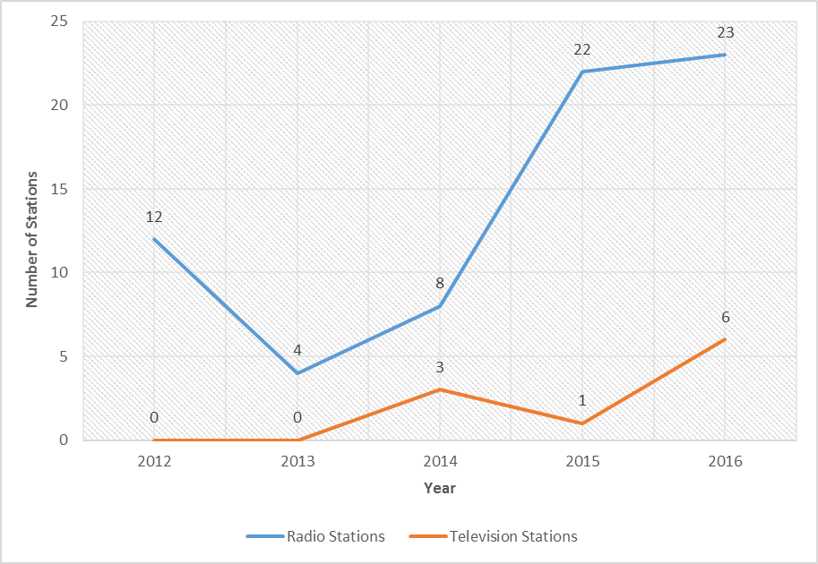
Source,TCRA, 2016

Press Cards Issued
Press Cards grant special privileges to journalists. The pass bears a recognized legal status; it is an identification criteria for practicing journalists in Tanzania. In Tanzania, Press Cards are issued to both local and foreign journalists upon application and meeting required criteria.

Table 3.4 and Figure 3.2 show that over a period of five years, 2012-2016, a total of 2,625 Press Cards were issued to journalists in Tanzania Mainland. Out of the issued Press Cards, 88.8 percent were for local journalists and 11.2 percent for foreigners. Moreover, trend of the issued Press Cards were fluctuating and was at the pick of 687 in 2015 due to General National Election.

Table 3.4: Number of Journalist Media Accreditation Cards (Press Cards) Issued, Tanzania Mainland; 2012 – 2016
Year | Local | Foreign | Total
2012 | 389 | 37 | 426
2013 | 475 | 25 | 500
2014 | 412 | 28 | 440
2015 | 551 | 136 | 687
2016 | 503 | 69 | 572
Total | 2,330 | 295 | 2,625
Percent | 88.8 | 11.2 | 100
Source: MICAS, Department of Information, 2016

Figure 3.2: Number of Press Cards Issued to Local and Foreign Journalists, Tanzania Mainland; 2012 - 2016
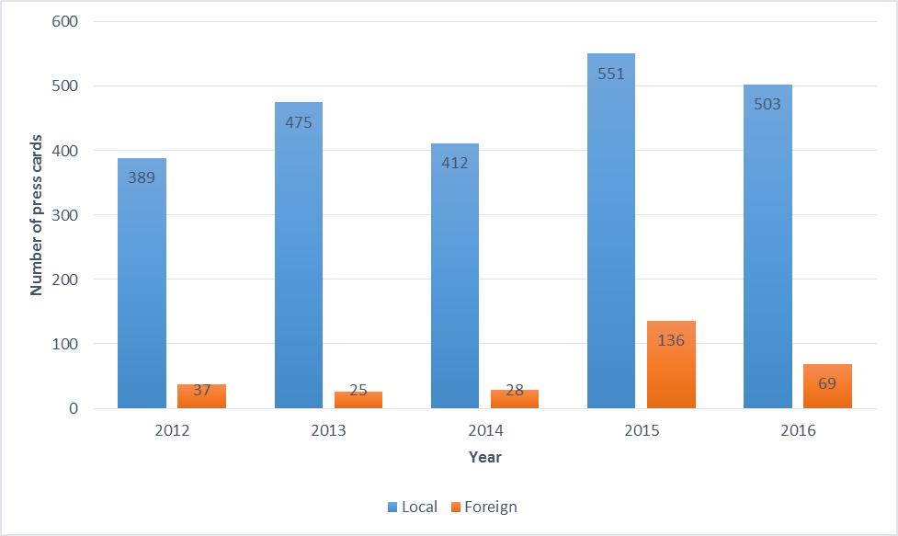
Source: MICAS, Department of Information, 2016

Registered Magazines
Printed and electronic media are dominant means of disseminating information in the modern world. Because of its affordability and accessibility even in rural area of the country newspapers recognized to be the most powerful tool for expressing ideas and exchanging information.

Over a five years period, 2012 – 2016, a total of 153 magazines were registered in Tanzania Mainland. Out of the registered magazines, a quarter of them (25.5 percent) were registered during a year of General National Election in 2015 (Table 3.5). The least number of magazines (26, 17.0 percent) were registered a year after General National Election (2016).

Table 3.5 Number of Registered Magazines, Tanzania Mainland; 2012 – 2016
Year | Number of Magazines/Journals | Percent
2012 | 29 | 19.0
2013 | 36 | 23.5
2014 | 23 | 15.0
2015 | 39 | 25.5
2016 | 26 | 17.0
Total | 153 | 100.0
Source: MICAS, Department of Information, 2016

Registered Swahili and English Newspapers
Table 3.6 shows that from 2012 to 2016, Tanzania Mainland registered 153 newspapers. More than fifty percent (57.5 percent) of the registered newspapers were of the national language, Swahili. Registered English language newspapers were 42.5 percent. Moreover, most of the Swahili language newspapers (25) were registered during a year of General National Election (2015) whilst English language newspapers (17) were mostly registered a year after General National Election (2016).

Table 3.6: Number of Registered Kiswahili and English Language Newspapers, Tanzania Mainland; 2012 – 2016
Year | English Language Newspapers | Swahili Language Newspapers | Total
2012 | 11 | 18 | 29
2013 | 14 | 22 | 36
2014 | 9 | 14 | 23
2015 | 14 | 25 | 39
2016 | 17 | 9 | 26
Total | 65 | 88 | 153
Percent | 42.5 | 57.5 | 100
Source: MICAS, Department of Information, 2016

Warned Newspapers
Findings presented in Table 3.7 indicate that a total of eight (8) registered newspapers and journals were warned during the 2012-2016 period. Of the warned newspapers and journals, the largest number (3) was warned in 2016. Basing on the fact that only eight (8) newspapers warned out of 153 registered newspapers in the country, this justifies that most of newspapers owners, editors and journalists abide by the existing policies, laws and regulations of the country.

Table 3.7:Number of Warned Newspapers, Tanzania Mainland; 2012 - 2016
Year | Number
2012 | 2
2013 | 0
2014 | 1
2015 | 2
2016 | 3
Total | 8
Source: MICAS, Department of Information, 2016

Banned Newspapers
These are newspapers whose operations have been stopped by the Government due to unethical conduct. Table 3.8 shows that from 2012 to 2016 only four (4) newspapers were banned following violation of the existing laws and regulations. However, with negligible number of banned newspapers (4) compared to the registered newspapers (153), this signifies that most newspapers owners, editors and journalists complied with the existing policies, laws and regulations governing the Media Sector.

Table 3.8:Number of Banned Newspapers, Tanzania Mainland; 2012 - 2016
Year | Number
2012 | 1
2013 | 2
2014 | 0
2015 | 0
2016 | 1
Total | 4
Source: MICAS, Department of Information, 2016

Sales of Newspapers by TSN
Over a five years period (2012-2016), number of newspapers produced (allocated) by TSN was in fluctuating trend (Table 3.9 and Figure 3.3). The produced newspapers were at the pick of 8,580,320 in 2013 and the lowest (6,072,575) in 2016. In general, data in Table 3.9 do not give much proof on when production is high, returned and sold newspapers will also be high and the vice versa. Likewise, the table highlights that, regardless of whether production of newspapers increased or decreased, returned newspapers are purely depending on sold newspapers.

Table 3.9: Number of Newspapers (Daily News, Habari Leo and Sports Leo) Allocated, Returned and Sold by TSN; 2012 – 2016
Year | Newspaper | Allocation | Returned | Sales | Percentage of sales
2012 | Daily News | 3,595,715 | 849,424 | 2,746,291 | 76
2012 | Habari leo | 2,031,809 | 866,223 | 1,165,586 | 57
2012 | Sports Leo | 862,078 | 849,424 | 12,654 | 1
2012 | Total | 6,489,602 | 2,565,071 | 3,924,531 | 60
2013 | Daily News | 4,798,828 | 1,359,342 | 3,439,486 | 72
2013 | Habari leo | 2,874,925 | 1,225,123 | 1,649,802 | 57
2013 | Sports Leo | 906,567 | 532,568 | 373,999 | 41
2013 | Total | 8,580,320 | 3,117,033 | 5,463,287 | 64
2014 | Daily News | 4,341,038 | 1,463,497 | 2,877,541 | 66
2014 | Habari leo | 2,811,579 | 1,349,605 | 1,461,974 | 52
2014 | Sports Leo | 820,328 | 450,150 | 370,178 | 45
2014 | Total | 7,972,945 | 3,263,252 | 4,709,693 | 59
2015 | Daily News | 4,149,511 | 1,201,269 | 2,948,242 | 71
2015 | Habari leo | 2,381,044 | 1,202,517 | 1,178,527 | 49
2015 | Sports Leo | 493,141 | 258,116 | 235,025 | 48
2015 | Total | 7,023,696 | 2,661,902 | 4,361,794 | 62
2016 | Daily News | 3,735,479 | 1,170,858 | 2,564,621 | 69
2016 | Habari leo | 1,981,282 | 1,167,470 | 813,812 | 41
2016 | Sports Leo | 355,814 | 196,621 | 159,193 | 45
2016 | Total | 6,072,575 | 2,534,949 | 3,537,626 | 58

Source: TSN, 2016

Figure 3.3: Percent of Sold Newspapers (Daily News, Habari Leo and Sports Leo) from 2012 to 2016
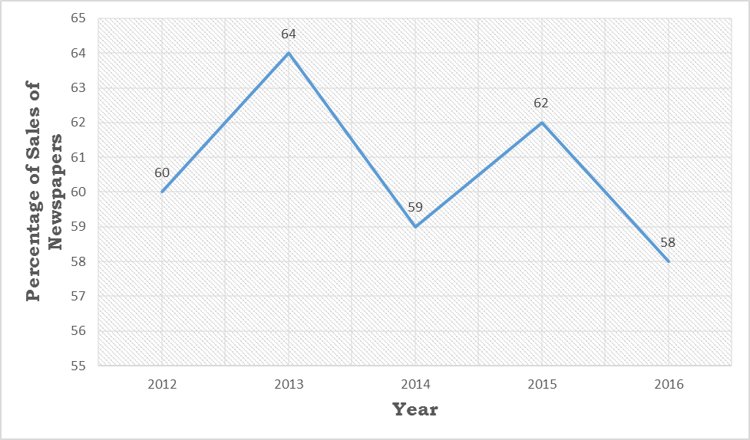

Source: TSN, 2016

Tanzania Broadcasting Corporation (TBC)
Tanzania Broadcasting Corporation (TBC) is a public broadcaster whose primary objective is to educate, entertain and provide information to the public through radio and television. TBC was established by a Presidential Order through Government Notice No. 186 of July, 2007. Currently TBC has two Television Channels; TBC1 and TBC2 and three Radio channels; TBC_{taifa}, TBC_{fm} and TBC _{international.}

As at December, 2016, radio coverage has reached 89 districts (in all regions of the Tanzania Mainland) while Television coverage has reached 18 regions through Digital Terrestrial Transmission (DTT) and Satellite transmission. In line to this, statistics produced by TBC are those concerning Radio and DTT coverage.

TBC Radio Coverage
Table 3.10 indicates that by December, 2016, 88 out of 161 districts in Tanzania Mainland (equivalent to 54.7 percent) had access to TBC radio signals. However, during the period under consideration (2012 – 2016), TBC radio signals transmission accessibility coverage remained constant (88 districts) due to Radio signal level improvements by reallocating some of transmitters in some of the districts.

Table 3.10: List of Districts covered by TBC Radio (TBC Taifa, TBC FM and TBC-International) and their frequencies, Tanzania Mainland; 2012-2016
No | District | TBC-Taifa Frequency (MHz) | TBC FM Frequency (MHz) | TBC-International -FM | No | District | TBC-Taifa Frequency (MHz) | TBC FM Frequency (MHz)
1 | Arumeru | 87.7 | 89.9 | - | 46 | Ilemela | 87.7 | 90.0
2 | Monduli | 87.7 | 89.9 | - | 47 | Ukerewe | 87.7 | 90.0
3 | Karatu | 87.7 | 89.9 | - | 48 | Misungwi | 87.7 | 90.0
4 | Arusha Urban | 87.7 | 89.9 | - | 49 | Nyamagana | 87.7 | 90.0
5 | Ilala | 87.8 | 90.0 | 95.3 | 50 | Sengerema | 87.7 | 90.0
6 | Kinondoni | 87.8 | 90.0 | 95.3 | 51 | Kibaha | 87.7 | 90.0
7 | Temeke | 87.8 | 90.0 | 95.3 | 52 | Kisarawe | 87.7 | 90.0
8 | Kigamboni | 87.8 | 90.0 | 95.3 | 53 | Mkuranga | 87.7 | 90.0
9 | Ubungo | 87.8 | 90.0 | 95.3 | 54 | Bagamoyo | 87.7 | 90.0
10 | Bahi | 87.7 | 89.7 | - | 55 | Mpanda | 87.7 | 89.7
11 | Chamwino | 87.7 | 89.7 | - | 56 | Sumbawanga Urban | 87.7 | 89.7
12 | Dodoma Urban | 87.7 | 89.7 | - | 57 | Songea Rural | 87.7 | 89.7
13 | Kondoa | 87.7 | 89.7 | - | 58 | Magu | 90.0 | 87.7
14 | Kongwa | 87.7 | 89.7 | - | 59 | Songea Urban | 87.7 | 89.7
15 | Mpwapwa | 87.7 |  | - | 60 | Namtumbo | 87.7 | 89.7
16 | Chemba | 87.7 |  | - | 61 | Tunduru | 87.9 | 89.9
17 | Iringa Urban | 87.7 | 89.7 |  | 62 | Shinyanga Urban | 87.9 | 89.9
18 | Kilolo | 87.7 | 89.7 |  | 62 | Singida Urban | 87.9 | 89.9
19 | Bukoba Urban | 87.7 | 89.7 | - | 64 | Tabora Urban | 87.9 | 89.9
20 | Bukoba Rural | 87.7 | 89.7 | - | 65 | Kaliua | 87.9 | 89.9
21 | Muleba | 87.7 | 89.7 | - | 66 | Nzega | 87.9 | 89.9
22 | Kyerwa | 87.7 | 89.7 | - | 67 | Sikonge | 87.9 | 89.9
23 | Misenyi | 87.7 | 89.7 | - | 68 | Uyui | 87.9 | 89.9
24 | Kasulu | 88.4 | 98.0 | - | 69 | Korogwe | 87.9 | 89.9
25 | Kigoma Urban | 88.4 | 98.0 | - | 70 | Muheza | 87.9 | 89.9
26 | Uvinza | 88.4 | 98.0 | - | 71 | Pangani | 87.9 | 89.9
27 | Kigoma Rural | 88.4 | 98.0 | - | 72 | Handeni | 87.9 | 89.9
28 | Bukombe | 87.7 | 90.0 | - | 73 | Kilindi | 87.9 | 89.9
29 | Buhigwe | 88.4 | 98.0 | - | 74 | Tanga Urban | 87.9 | 89.9
30 | Hai | 89.9 | 90.0 | - | 75 | Chato | 87.7 | 90.0
31 | Kilimanjaro | 89.9 | 90.0 | - | 76 | Mbeya Urban | 92.3 | 100.4
32 | Kilimanjaro Rural | 89.9 | 90.0 | - | 77 | Mbeya Rural | 92.3 | 100.4
33 | Mwanga | 89.9 | 90.0 | - | 78 | Mbozi | 92.3 | 100.4
34 | Same | 89.9 | 90.0 | - | 79 | Morogoro Urban | 87.9 | 105.9
35 | Siha | 89.9 | 90.0 | - | 80 | Newala | 100.9 | 97.4
36 | Lindi Urban | 87.9 | 89.9 | - | 81 | Tandahimba | 100.9 | 97.4
37 | Lindi Rural | 87.9 | 89.9 | - | 82 | Kwimba | 87.7 | 90.0
38 | Ruangwa | 87.9 | 89.9 | - | 83 | Kakonko | 88.4 | 98.0
39 | Masasi | 87.9 | 89.9 | - | 84 | Musoma Urban | 87.9 | 89.9
40 | Liwale
41 | Nachingwea | 87.9 | 89.9 | - | 85 | Rorya | 87.9 | 89.9
42 | Babati | 87.9 | 89.9 | - | 86 | Butiama | 87.9 | 89.9
43 | Hanang | 87.9 | 89.9 | - | 87 | Chunya | 92.3 | 100.4
44 | Mbulu | 87.9 | 89.9 | - | 88 | Nyang’wale | 87.7 | 89.7
45 | Mbarali | 92.3 | 100.4 | -
Source: TBC, 2016

Television Coverage in Tanzania Mainland
Table 3.11 shows that from 2010 to 2016, 18 regions in Tanzania Mainland had access to digital terrestrial broadcasting. On the other hand, migration from the use of Satellite Transmission (ST) to Digital Terrestrial Transmission (DTT) is done by phases.

Table 3.11: Distribution of Regions Covered with Digital Platform, Tanzania Mainland; 2010 - 2016
No | Region | Year | Digital (DTT) | Satellite (ST)
1 | Coast | 2010 | Digital Transmission | Satellite Transmission
2 | Arusha | 2011 | Digital Transmission | Satellite Transmission
3 | Dodoma | 2011 | Digital Transmission | Satellite Transmission
4 | Kilimanjaro | 2011 | Digital Transmission | Satellite Transmission
5 | Mbeya | 2011 | Digital Transmission | Satellite Transmission
6 | Mwanza | 2011 | Digital Transmission | Satellite Transmission
7 | Tanga | 2011 | Digital Transmission | Satellite Transmission
8 | Morogoro | 2012 | Digital Transmission | Satellite Transmission
9 | Kagera | 2013 | Digital Transmission | Satellite Transmission
10 | Shinyanga | 2013 | Digital Transmission | Satellite Transmission
11 | Singida | 2013 | Digital Transmission | Satellite Transmission
12 | Dar es Salaam | 2013 | Digital Transmission | Satellite Transmission
13 | Tabora | 2013 | Digital Transmission | Satellite Transmission
14 | Ruvuma | 2014 | Digital Transmission | Satellite Transmission
15 | Iringa | 2014 | Digital Transmission | Satellite Transmission
16 | Kigoma | 2015 | Digital Transmission | Satellite Transmission
17 | Mara | 2015 | Digital Transmission | Satellite Transmission
18 | Mtwara | 2015 | Digital Transmission | Satellite Transmission
Source: TBC, 2016

List of Districts not covered by TBC Radio Frequency by 2016
Table 3.12 shows that by 2016, 70 out of 161 districts had no access to TBC Radio frequency. This was equivalent to 43.5 percent of all districts in Tanzania Mainland.

Table 3.12: List of Districts not covered by TBC Radio Frequency; 2016
No | Region | District | No | Region | District
1 | Arusha | Arusha Rural Area | 36 | Coast | Rufiji
2 | Arusha | Ngorongoro | 37 | Coast | Kibiti
3 | Arusha | Longido | 38 | Ruvuma | Mbinga
4 | Geita | Geita Urban | 39 | Ruvuma | Nyasa
5 | Geita | Mbogwe | 40 | Rukwa | Sumbawanga Rural
6 | Iringa | Mufindi | 41 | Rukwa | Nkasi
7 | Iringa | Mafinga Urban | 42 | Rukwa | Kalambo
8 | Kigoma | Kibondo | 43 | Shinyanga | Shinyanga Rural
9 | Kigoma | Kasulu Urban | 44 | Shinyanga | Kahama Urban
10 | Kilimanjaro | Rombo | 45 | Shinyanga | Kahama Rural
11 | Lindi | Kilwa | 46 | Shinyanga | Kishapu
12 | Mbeya | Rungwe | 47 | Simiyu | Bariadi
13 | Mbeya | Kyela | 48 | Simiyu | Busega
14 | Mbeya | Busekelo | 49 | Simiyu | Itilima
15 | Mara | Bunda | 50 | Simiyu | Maswa
16 | Mara | Tarime | 51 | Simiyu | Meatu
17 | Mara | Serengeti | 52 | Songwe | Mbozi
18 | Mtwara | Mtwara Rural | 53 | Songwe | Songwe
19 | Mtwara | Mtwara Urban | 54 | Songwe | Momba
20 | Mtwara | Nanyumbu | 55 | Songwe | Ileje
21 | Morogoro | Morogoro Rural | 56 | Tanga | Mkinga
22 | Morogoro | Mvomero | 57 | Tanga | Lushoto
23 | Morogoro | Gairo | 58 | Tabora | Tabora Rural
24 | Morogoro | Kilosa | 59 | Tabora | Urambo
25 | Morogoro | Kilombero | 60 | Tabora | Igunga
26 | Morogoro | Ulanga | 61 | Njombe | Njombe Urban
27 | Morogoro | Malinyi | 62 | Njombe | Njombe Rural
28 | Kagera | Biharamulo | 63 | Njombe | Waging'ombe
29 | Kagera | Karagwe | 64 | Njombe | Makete
30 | Kagera | Ngara | 65 | Njombe | Ludewa
31 | Manyara | Babati Rural | 66 | Njombe | Kakambako
32 | Manyara | Kiteto | 67 | Singida | Ikungi
33 | Manyara | Simanjiro | 68 | Singida | Iramba
34 | Katavi | Mlele | 69 | Singida | Manyoni
35 | Katavi | Tanganyika | 70 | Singida | Mkalama

Source: TBC, 2016

Culture Statistics
Culture is recognized as “all aspects that have been created by a society in order to satisfy its needs and enable it to develop further. In other words, culture is the totality of a society’s ways of life, which distinguish it from other societies. Thus culture is a society’s main identity” (Cultural Policy, 1997).

UNESCO defines culture as the set of distinctive spiritual, material, intellectual and emotional features of society or a social group, that encompasses, not only art and literature, but lifestyles, ways of living together, value systems, traditions and beliefs (UNESCO, 2002).

The Cultural Sector has become increasingly important in the Socio-economic development in Tanzania. For this reason, cultural statistics evidences in growth of sustainable cultural development. In Tanzania, the cultural sector is coordinated by the Department of Culture in collaboration with the National Kiswahili Council (BAKITA) and African Liberation Heritage Programme. This section gives data on the following areas; Liberation Heritage Sites and Language Sector.

African Liberation Heritage sites in Tanzania
Tanzania has various sites used during the African liberation movements. These areas are preserved and developed as liberation heritage sites. The Ministry, through the African Liberation Heritage Programme continues to identify, protect and preserve liberation heritage for both current and future generations. The heritage includes freedom fighters grave yards, military training camps and various sites used at time of the liberation struggle. Tanzania was nominated by the Organization of African Union (OAU) Secretariat and later African Union (AU) to be the headquarters of the African Liberation Heritage Programme.

Table 3.13 shows that by 2016, Tanzania Mainland had identified 156 African Liberation Heritage Sites. Dar es Salaam Region had the highest number of Sites (69) followed by Ruvuma (12 Sites). Arusha and Kagera regions (each with one heritage site) had the least number.

Table 3.13: African Liberation Heritage Sites by Regions, Tanzania Mainland; 2016
No | Region | Heritage Sites
1 | Dar Es Salaam | 69
2 | Mwanza | 2
3 | Mbeya | 9
4 | Mtwara | 10
5 | Lindi | 3
6. | Ruvuma | 12
7. | Coast | 5
8. | Iringa | 8
9. | Dodoma | 11
10 | Tabora | 7
11 | Kigoma | 2
12 | Tanga | 3
13 | Morogoro | 11
14 | Mara | 2
15 | Arusha | 1
16 | Kagera | 1
 | Total | 156
Source: African Liberation Heritage Programme 2016

Services Offered by BAKITA
The National Kiswahili Council (BAKITA) was established by Parliamentary Act No. 27 of 1967 which was revised in 1983 and amended in 2016. The Council is responsible for overseeing the use and development of Kiswahili language in the country and abroad.
In implementing its role, BAKITA provides education on language use through media, approves correct use of Kiswahili in Literature textbooks intended to be used for schools, provides consultancies and editing services to young and longstanding writers, and provides translation and interpretation services to institutions, companies, organizations, AU, OAU, African Parliament and individuals.
During the reference period shown in Table 3.14, BAKITA provided six types of services. Number of Radio and Television programmes aired by BAKITA was 1,008, language approval services (especially approval of books were 311), translation (2,410), interpretation (25), editing (73) and language mistakes identified in the media (8,174). Further observation of Table 3.14 reveals that Radio and Television programmes aired by BAKITA remained static at 156 in five years, 2010 – 2014 and thereafter dropped significantly to reach 118 in 2015 and 110 in 2016 respectively. Furthermore, language approval services were at the pick of 121 in 2015 because the Council received bulk of books from the Tanzania Institute of Education as a result of changes made in the curriculum used in primary schools. Concerning identifying language mistakes in the media, Table 3.14 shows number of the identified language mistakes was higher during the first three years (2010 – 2012) of the period under consideration than the remaining four years (2013 – 2016).

Table 3.14: Number of Services Provided By BAKITA From 2010 to 2016
Year | Radio and Television Programmes | Language Approval Services | Translation | Interpretation | Editing | Language Mistakes in the Media | Percent
2010 | 156 | 24 | 300 | 3 | 9 | 1300 | 15.9
2011 | 156 | 27 | 350 | 4 | 10 | 1248 | 15.3
2012 | 156 | 25 | 280 | 5 | 9 | 1248 | 15.3
2013 | 156 | 30 | 400 | 5 | 10 | 1120 | 13.7
2014 | 156 | 24 | 410 | 3 | 7 | 1010 | 12.4
2015 | 118 | 121 | 320 | 3 | 8 | 1200 | 14.7
2016 | 110 | 60 | 350 | 2 | 20 | 1048 | 12.8
Total | 1,008 | 311 | 2,410 | 25 | 73 | 8,174 | 100.0
Source: BAKITA

Figure 3.4: Number of Mistakes of Kiswahili Language in Media, Tanzania Mainland; 2010 - 2016
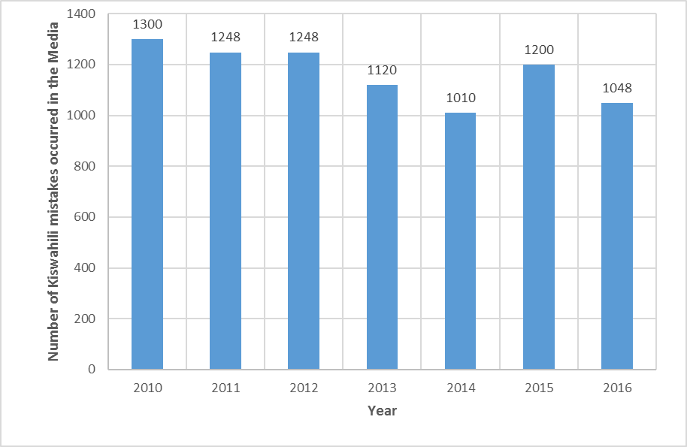
Source: BAKITA

Arts Statistics

The proposed Arts Department in the Ministry was established in 2015 and mandated to coordinate all matters concerning Arts in Tanzania. Before that, Arts was a section within Culture Department. The Arts Department has three sections which are: Fine and Performing Arts and Music, Artists Development and Empowerment and Film Development section (Currently, the Department isn’t fully fledged, it awaits for Presidential approval of the newly proposed Ministry’s organization structure).
The proposed Department coordinates development of Arts in collaboration with Government institutions namely; Bagamoyo Institute of Arts and Culture (TaSUBa), Tanzania Film Board (TFB) and the National Arts Council (BASATA).

This section includes data on: number of participants at Bagamoyo Arts and Cultural Festival, students enrollment and graduates at TaSUBa, registered artist groups, arts promoters and arts associations, individual artists in performing arts and music, recreation halls, number of licensed cultural events, banned music (songs), foreign and local Artists performances, local and international awards in music and film, film classification and certification, filming permits, confiscated illegal film and music products, banned music and films, and Tax stamps.

Cultural Groups Participation at Bagamoyo Arts and Cultural Festival
TaSUBa in collaboration with other stakeholders have been organizing the Bagamoyo Arts and Cultural Festival since 1982. Table 3.15 below indicates that the participation of local cultural groups ranged from 40 in 2012 to 83 in 2016 while foreign cultural groups ranged from 4 in 2012 to 5 in 2013. Furthermore, the number of local participants increased significantly from 48 in 2015 to 83 in 2016 (72.9 percent increase). This increase was due to awareness raised to local cultural groups, involvement of stakeholders during festival preparations, increase of advertisements for the festival and increase of financial support for the participating groups.

Table 3.15: Number of Local and Foreign Cultural Groups Participation at the Bagamoyo Arts and Cultural Festival, Tanzania Mainland; 2012 – 2016
Year | Cultural Groups |  | Total
Year | Local | Foreign | Total
2012 | 40 | 4 | 44
2013 | 43 | 5 | 48
2014 | 45 | 4 | 49
2015 | 48 | 4 | 52
2016 | 83 | 4 | 87
Source; TaSUBA, 2016

Diploma Students Enrolled and Graduated at TaSUBa
The number of Diploma students enrolled at TaSUBa from 2012 to 2016 is shown in Table 3.16 below. The table reveals that the total number of students enrolled decreased by 8.3 percent from 48 in 2012 to 44 students in 2016. The analysis further reveals that, the number of male students enrolled increased by 15.2 percent from 33 students in 2015 to 38 students in 2016. On the other hand, the number of female students decreased by 57.1 percent from 14 students in 2015 to 6 students in 2016. This decrease was due to inadequate financial support for female students to study arts and culture courses and the cancellation of admitting students with less than four (4) passes and Primary School leavers to study a two year certificate course.

Table 3.16: Number and Percentage of Diploma Students Enrolled at TaSUBa by Sex, Tanzania Mainland; 2012 - 2016
Year | Number |  |  | Percent
Year | Males | Females | Total | Male | Female
2012 | 30 | 18 | 48 | 62.5 | 37.5
2013 | 38 | 26 | 64 | 59.4 | 40.6
2014 | 54 | 9 | 63 | 85.7 | 14.3
2015 | 33 | 14 | 47 | 70.2 | 29.8
2016 | 38 | 6 | 44 | 86.3 | 13.7
Source: TaSUBa, 2016

Table 3.17 below shows the number of diploma male students who graduated from TaSUBa were higher than that of females. The table also reveals that the number of male students who graduated decreased by 16.2 percent from 37 students in 2015 to 31 students in 2016. The number of female students who graduated decreased from 23 in 2015 to 19 in 2016 (17.4%).

Table 3.17: Number and Percentage of Diploma Graduates From TaSUBa, Tanzania Mainland; 2012 - 2016
Year | Number |  |  |  | Percent
Year | Male | Female | Total |  | Male | Female
2012 | 25 | 10 | 35 |  | 71.4 | 28.6
2013 | 32 | 12 | 44 |  | 72.7 | 27.3
2014 | 23 | 12 | 35 |  | 65.7 | 34.3
2015 | 37 | 23 | 60 |  | 61.7 | 38.3
2016 | 31 | 19 | 50 |  | 62.0 | 38.0
Source: TaSUBa, 2016

Figure 3.5: Distribution of Diploma Graduates From TaSUBa, Tanzania Mainland; 2012 - 2016
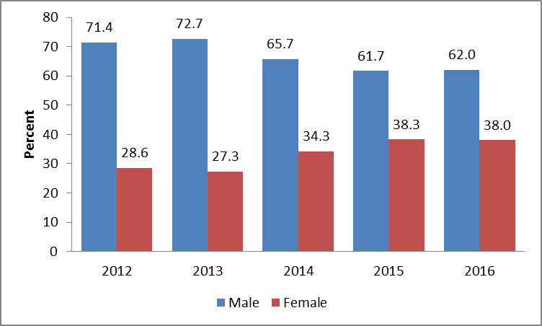

Source: TaSUBa, 2016

Audience at the Bagamoyo Arts and Cultural Festival
Table 3.18 below shows that in total, 59,352 audiences attended the Bagamoyo Arts and Cultural Festival in 2015 and 2016. Furthermore, it is revealed that there were more females (37,970) which is equivalent to 64.0 percent compared to males 21,382 (36 percent).

Table 3.18: Audience at Bagamoyo Arts and Cultural Festival; 2015 and 2016
Year | No. of Male | No. of Female | Total | Percent
 |  |  |  | Male | Female
2015 | 11,314 | 16,970 | 28,284 | 40 | 60
2016 | 10,068 | 21,000 | 31,068 | 32 | 68
TOTAL | 21,382 | 37,970 | 59,352 | 36 | 64

Source: TaSUBa, 2016

The Figure 3.6: Percentage of Male and Female Audience at Bagamoyo Arts and Cultural Festival; 2015 and 2016

Source: TaSUBa, 2016

Number of Graduates in Short Courses
Table 3.19 presents number of graduates in various short courses at TaSUBa. The total number of Short Course Students graduated decreased from 256 in 2013 to 74 in 2016. On the other hand, in 2016 the majority of students (21) graduated in Music and Fine Arts courses each, followed by Film and TV Production, and Music and Sound Production with 10 students each. However, Swahili Fashion Design and Stage Technology courses recorded the least number of graduates (1 each). The decrease of graduates from 256 in 2013 to 74 in 2016 among other reasons was due to mushrooming of training centers on arts and culture courses, and lack of awareness and understanding of the society on studies about performing and visual arts.

Table 3.19: Number of Graduates at TaSUBa by Course and Sex, Tanzania Mainland; 2013-2016
Course | 2013 |  |  | 2014 |  |  | 2015 |  |  | 2016
Course | Male | Female | Total | Male | Female | Total | Male | Female | Total | Male | Female | Total
Music | 42 | 29 | 71 | 49 | 27 | 76 | 25 | 22 | 47 | 14 | 7 | 21
Fine Arts | 41 | 30 | 71 | 43 | 33 | 76 | 31 | 16 | 47 | 10 | 11 | 21
Drama | 5 | 8 | 13 | 8 | 6 | 14 | 5 | 3 | 8 | 1 | 2 | 3
Dance | 3 | 2 | 5 | 2 | 3 | 5 | 1 | 2 | 3 | - | 2 | 2
Film & TV Production | 20 | 17 | 36 | 31 | 7 | 38 | 16 | 8 | 24 | 5 | 5 | 10
Music & Sound Production | 23 | 12 | 35 | 35 | 3 | 38 | 20 | 3 | 23 | 8 | 2 | 10
Stage Technology | 3 | - | 3 | 2 | 1 | 3 | 1 | 1 | 2 | 1 | - | 1
Fashion Design | 1 | 2 | 3 | - | 3 | 3 | - | 2 | 2 | - | 1 | 1
Kiswahili | 1 | 2 | 3 | 2 | 1 | 3 | - | 2 | 2 | - | 1 | 1
Computer Studies | 7 | 8 | 15 | 9 | 8 | 17 | 7 | 3 | 10 | 1 | 3 | 4
Total | 146 | 110 | 256 | 181 | 92 | 273 | 106 | 62 | 168 | 40 | 34 | 74

Source: TaSUBa, 2016

Figure 3.7: Number of Graduates at TaSUBa, Tanzania Mainland; 2013 – 2016
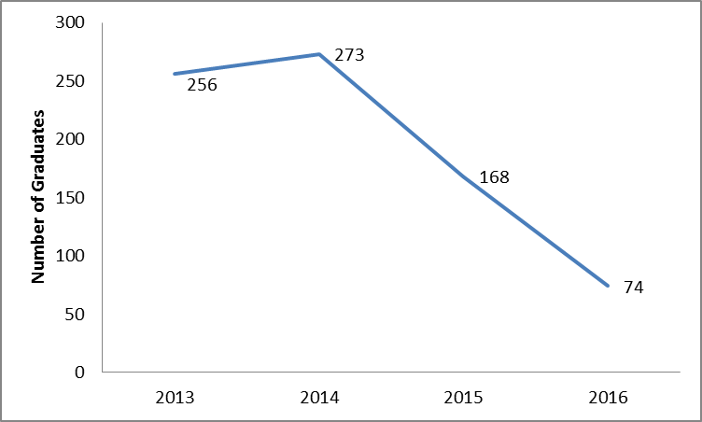
Source: TaSUBa

Theatre/Drama and Music Groups Registered

The National Arts Council is a Government Institution established under Act No. 23 of 1984. The Council is endowed with the responsibility of coordinating and supporting operations and development of the arts sector in Tanzania Mainland. The Council is entitled to register individual artists, arts groups, associations, federations, arts promoters, entertainment halls, arts training institutions and Non-Governmental Organizations (NGOs) in the fields of arts.
Table 3.20 shows that over a period of seven years (2010 – 2016), Tanzania Mainland had 654 Theatre/Drama and 519 music groups. Dar es Salaam Region is leading among the list in Theatre/Drama groups (240) or 36.7percent followed by Morogoro 47 groups (7.2 percent). Rukwa and Songwe had the least number of registered Theatre/Drama groups (2, 0.3 percent each). Comparatively, Dar es Salaam is dominating by having the largest number of music arts groups at 209 (40.3 percent) followed by Mbeya Region 60 groups (11.6 percent). Songwe, Ruvuma and Simiyu had no registered music arts groups.

Table 3.20: Number of Registered Theatre/Drama and Music groups by Region, Tanzania Mainland from 2010 to 2016
SN | Region | Theatre/Drama | Music Artist
1 | Dar es Salaam | 240 | 209
2 | Dodoma | 14 | 22
3 | Arusha | 30 | 38
4 | Morogoro | 47 | 20
5 | Tanga | 15 | 7
6 | Shinyanga | 16 | 17
7 | Mbeya | 23 | 60
8 | Tabora | 4 | 21
9 | Mwanza | 31 | 23
10 | Mtwara | 42 | 4
11 | Kilimanjaro | 12 | 18
12 | Coast | 29 | 14
13 | Lindi | 15 | 2
14 | Manyara | 16 | 7
15 | Njombe | 12 | 14
16 | Mara | 10 | 1
17 | Iringa | 15 | 19
18 | Kagera | 12 | 6
19 | Kigoma | 10 | 7
20 | Rukwa | 2 | 2
21 | Geita | 8 | 5
22 | Songwe | 2 | 0
23 | Katavi | 5 | 2
24 | Singida | 6 | 1
25 | Ruvuma | 34 | 0
26 | Simiyu | 4 | 0
 | TOTAL | 654 | 519

Source: BASATA, 2016

Individual Artists Registered
Table 3.21 below reveals that the total number of registered individual artists increased from four (4) in 2012 to 248 in 2015. However, it decreased slightly to 243 in 2016. In addition there is the large number of individual music registered artists which increased from 3 in 2012 to 186 in 2016. This is followed by performing arts which increased from 13 in 2014 to 31 in 2016. Crafts recorded the lowest individual artists registered ranging from 3 in 2014 to 11 in 2016.

Table 3.21: Registered Individual Artists of Films, Crafts, Performing Arts and Music, Tanzania Mainland; 2012 - 2016
Year | Films | Crafts | Performing Arts | Music | Total
2012 | 1 | 0 | 0 | 3 | 4
2013 | 1 | 5 | 0 | 8 | 14
2014 | 2 | 3 | 13 | 132 | 150
2015 | 5 | 4 | 10 | 229 | 248
2016 | 15 | 11 | 31 | 186 | 243
Source; BASATA, 2016

Licensed Cultural Events
Since the adoption of the Cultural Policy in 1997, the National Arts Council (BASATA) was mandated to coordinate and license cultural events in Tanzania. Among others, the Council is obliged to register cultural events. Table 3.22 below shows that there were 122 licensed cultural events recorded from 2011/12 to 2015/16. Furthermore, the number of licensed cultural events decreased by 58.3 percent from 24 in 2014/15 to 10 in 2015/16. Figure 3.8 shows the proportion of licensed cultural events over the period 2011/12 to 2015/16.

Table 3.22: Number of Licensed Cultural Events, Tanzania Mainland; 2011/2012- 2015/2016
Year | Cultural Events
2011/12  2012/13 | 21  32
2013/14 | 35
2014/15  2015/16 | 24  10
Total | 122
Source: BASATA, 2016

Figure 3.8: Licensed Cultural Events from 2011/12 - 2015/16
Source: BASATA, 2016

Permits issued to Foreign Artists who Performed in Tanzania
The National Arts Council is also mandated to issue permits to foreign artists performing in Tanzania Mainland. As Table 3.23 shows, the number of permits issued to foreign artists was at the pick of 44 in 2012 and the lowest (19) in 2015.

Table 3.23: Permits issued to Foreign Artists, Tanzania Mainland; 2012 – 2016
Year | Number of Permit
2012 | 44
2013 | 39
2014 | 27
2015 | 19
2016 | 35
Source: BASATA, 2016

Number of Permits issued to Local Artists Performed Outside the Country
Table 3.24 indicates the number of permits issued to Tanzanian artists who performed outside the country from 2012 to 2016. The data reveals that, for the period from 2012 to 2015 there was a slight change in number of permits issued ranging from 1 in 2012 to 5 in 2015. In 2016 the number of permits issued increased substantially to 15. This was a result of awareness campaign to stakeholders on the requirement to apply for permits before leaving the country.

Table 3.24: Permits issued to Local Artists Performing Outside the Country, Tanzania Mainland; 2012 – 2016
Year | Number of Permits
2012 | 1
2013 | 1
2014 | 5
2015 | 5
2016 | 15
Total | 27
Source: BASATA, 2016

Foreign Artists Performing in the country
Table 3.25 and Figure 3.9 show increasing trend of the number of Foreign Artists who performed in the country. Their number was the lowest (86 artists, 10.1 percent) in 2012 and the highest (350 artists, 41.0 percent) in 2016.

Table 3.25: Foreign Artists who Performed within the Country from 2012 – 2016
Year | Number of Foreign Artists | Percentage
2012 | 86 | 10.1
2013 | 109 | 12.8
2014 | 127 | 14.9
2015 | 182 | 21.3
2016 | 350 | 41.0
TOTAL | 854 | 100.0
Source: BASATA, 2016

Figure 3.9: Distribution of Foreign Artists who Performed within the country from 2012 – 2016
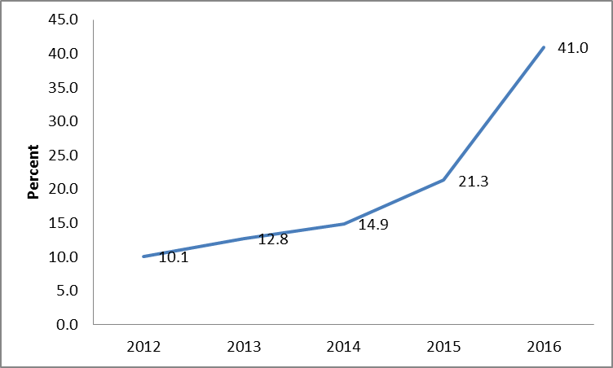
Source: BASATA, 2016

Local Artists who performed Outside the Country from 2011 to 2016
Table 3.26 shows the number of Local Artists who performed outside the country increased significantly from one in 2012 and 2013 to 32 in 2016. Remarkable decrease on the number of local artists performed outside the country was from 29 in 2014 to 15 in 2015. This decrease was associated to their involvement in 2015 General National Election campaigns.

Table 3.26: Local Artists who Performed Outside the Country;2011 – 2016
Year | Number of Local Artists
2011 | 2
2012 | 1
2013 | 1
2014 | 29
2015 | 15
2016 | 32
Source: BASATA, 2016

Local and International Awards (Trophies) Won by Local Artists
From 2011/12 to 2015/16 a total of 193 awards were won by artists. Local awards dominated with 171 awards against 22 international awards. Local awards decreased from 46 in 2014/15 to 30 in 2015/16 (34.8 percent decrease). On the other hand, international awards decreased from 8 in 2014/15 to 5 in 2015/16 (37.5 percent decrease). The decrease of local awards in 2015/16 was because the Kilimanjaro and other Music Awards were not held which in most cases would have attracted local winners.

Table 3.27: Local and International Awards (Trophies) Won by Local Artists Tanzania Mainland; 2011/12 – 2015/16
Year | Number of Local Awards | Number of International Awards | Total
2011/12 | 24 | 0 | 24
2012/13 | 23 | 3 | 26
2013/14 | 48 | 6 | 54
2014/15  2015/16 | 46  30 | 8  5 | 54  35
Total | 171 | 22 | 193
Source: BASATA, 2016

Banned Music (songs) From 2011/12 to 2015/16
The National Arts Council facilitâtes production and consomption of good art woks in Music, théâtre and fine art. Generally, Music (songs) with illicit content are banned due to unethical conduct, and violation of laws and régulations governing the industry.

From 2011/12 to 2013/14 no local or foreign music (songs) were banned. Musicians complied with the existing laws and regulations governing the Sector. Figure 3.10 shows that during a period of 2014/15 and 2015/16 four (4) local music songs were banned.

Figure 3.10: Banned Local Music (songs); 2014/15 and 2015/2016
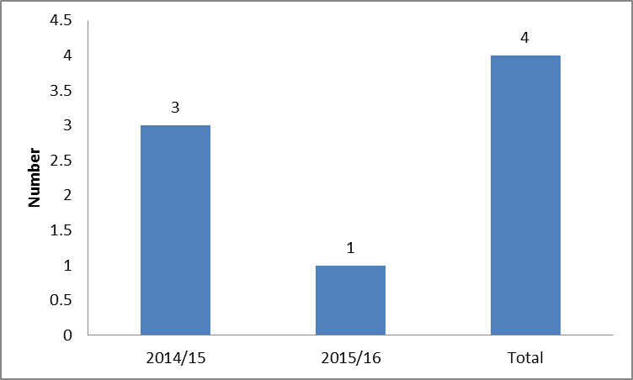
Source: BASATA 2016

Registered Arts Promoters and Associations from 2012 – 2016
Table 3.28 below shows that from 2012 to 2016 there was 342 arts promoters and 77 arts associations registered. In addition, the number of arts promoters increased from 51 in 2012 to 90 in 2016, while the number of arts associations increased from 13 in 2012 to 25 in 2016. The increase was mainly attributed by awareness raised to arts stakeholders and the formalization of the Film and Music Industry.

Table 3:28: Registered Arts Promoters and Associations from 2012 – 2016
Year | Number of promoters | Number of Associations
2012 | 51 | 13
2013 | 53 | 10
2014 | 74 | 10
2015 | 74 | 19
2016 | 90 | 25
TOTAL | 342 | 77
Source: BASATA

Figure 3.11: Registered Arts Promoters and Associations; 2012 – 2016
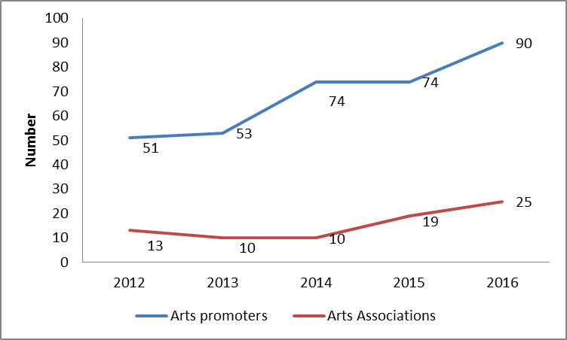
Source: BASATA, 2016

Film and Stage Plays Industry

The Film and Stage Plays Industry in Tanzania is one of the most vibrant owing to its ability to employ about 732,690 people from different groups in 2016 (TFB 2016). The Film Industry is regulated under the Films and Stage Plays Act No. 4 of 1976 and its Regulations of 2011. This Act puts in place the Tanzania Film Board, a government institution mandated to regulate and coordinate the Film Industry. Tanzania Film Board is also responsible for the overall development of the Film and Stage Plays Industry.

Tanzania Film and Stage Plays Industry produces up to 1,400 films per year making Tanzania the second largest producer of motion pictures in Africa, after Nigeria, in terms of number of productions.

This section focuses on the number of film permits issued, reviewed movie Scripts, classified and certified films, illegal local films found in the markets, film and music products with special revenue stamps, awarded films (local and international), film infrastructures and banned films, Accreditation film practitioners’ licenses and registered practicing identity card issued.

Filming Permits
Table 3.29 below shows that 753 filming permits were issued from 2011/12 to 2015/16. It further indicates that, more foreign permits were issued compared to local permits with 602 and 151 respectively. Likewise, Figure 3.12 shows the trend of local filming permits issued in the same period. The least number of local filming permits is associated with lack of awareness and financial constraints to local film makers.

Table 3.29: Filming Permits Issued by Type, Tanzania Mainland; 2011/12 - 2015/16
Type of Permit | 2011/12 | 2012/13 | 2013/14 | 2014/15 | 2015/16 | Total
Local | 21 | 30 | 33 | 36 | 31 | 151
Foreign | 84 | 123 | 125 | 133 | 137 | 602
Total | 105 | 153 | 158 | 169 | 168 | 753
Source: Tanzania Film Board, 2016

Figure 3.12: Local and Foreign Filming Permits, Tanzania Mainland; 2011/12 – 2015/16
Source: Tanzania Film Board, 2016

Classified and Certified Films
Among other duties, the Tanzania Film Board is mandated to examine, classify and issue certificates of approval to film and stage plays before they are exhibited. Table 3.30 below shows the number of films classified and certified from 2011/12 to 2015/16. During that period, there were a total of 3,803 local and 257 foreign classified and certified films. Figure 3.13 below narrates the trend in numbers of classified and certified film permits.

Table 3.30: Classified and Certified Films by Category, Tanzania Mainland; 2011/12 - 2015/16
Category | 2011/12 | 2012/13 | 2013/14 | 2014/15 | 2015/16 | Total
Number of Local films | 216 | 414 | 1,181 | 1,339 | 653 | 3,803
Number of Foreign films | 12 | 12 | 58 | 61 | 114 | 257
Total | 228 | 426 | 1,239 | 1,400 | 767 | 4,060
Source: Tanzania Film Board, 2016

Figure 3.13: Classified and Certified Films by Category, Tanzania Mainland; 2011/12 – 2015/16
Source: Tanzania Film Board, 2016

Illegal Film Products Confiscated
Illegal films refer to film products found in the local black market. Table 3.31 below shows that a total of 747,100 illegal films were confiscated in the period between 2013/14 to 2015/16, whereby the largest number was foreign films (694,793) and 52,307 local. Furthermore, the analysis indicates that local films products confiscated decreased from 31,156 in 2014/15 to 6,478 in 2015/16. On the other hand, illegal foreign film products confiscated increased from 35,166 in 2014/15 to 650,101 in 2015/16. It is important to note that, the Government in collaboration with other stakeholders continued to wipe out pirated film products in the market in order to increase its revenue and hence empowering the local artists.

Table 3.31: Illegal Film Products Confiscated, Tanzania Mainland; 2013/14 – 2015/16
Category | 2013/14 | 2014/15 | 2015/16 | Total
Local | 14,673 | 31,156 | 6,478 | 52,307
Foreign | 9,526 | 35,166 | 650,101 | 694,793
Total | 24,199 | 66,322 | 656,579 | 747,100
Source: Tanzania Revenue Authority TRA, 2016.

Tax Stamps for Film and Music Products
In 2013, the government introduced special stamps for film and music products in order to establish the number of film and music products available in the market, control piracy, maintain copyright, and hence increase government revenue. Table 3.32 shows that 21,830,000 films and 6,110,000 music products were issued with tax stamps from 2013/14 to 2015/16. It is observed that the number of film products issued with tax stamps decreased relatively to the number of music products issued with tax stamps.

Table 3.32: Tax Stamps by Type, Tanzania Mainland; 2013/14 - 2015/16
Type | 2013/14 | 2014/15 | 2015/16 | Total
Films | 3,810,000 | 13,100,000 | 4,920,000 | 21,830,000
Music | 570,000 | 3,200,000 | 2,340,000 | 6,110,000
Total | 4,380,000 | 16,300,000 | 7,260,000 | 27,940,000
Source: Tanzania Revenue Authority TRA, 2016

Banned Films
Tanzania Film Board is responsible for ensuring adherence to cultural ethics and aesthetics in films and stage plays exhibited to the public. Therefore, films which violate cultural ethics and aesthetics are banned from distribution. From 2011/12 to 2015/16, 15 films were banned for public use with the largest number of foreign films compared to local films (Table 3.33).

Table 3.33: Banned Films by Type, Tanzania Mainland; 2011/12 - 2015/16
Type | 2011/12 | 2012/13 | 2013/14 | 2014/15 | 2015/16 | Total
Local | 1 | 0 | 2 | 1 | 2 | 6
Foreign | 3 | 0 | 5 | 1 | 0 | 9
Total | 4 | 0 | 7 | 2 | 2 | 15
Source: Tanzania Film Board, 2016

Film Awards
Table 3.34 below shows the number of local and international film awards won by Tanzanians. In the period 2012 and 2016, a total of 41 awards were won whereby, local awards dominated with 32 awards and 9 International Awards. On the other hand, local awards decreased from 12 in 2015 to 11 in 2016. However, International Awards increased from 1 in 2015 to 4 in 2016. The increase was due to quality improvement of local films.

Table 3.34: Local and International Film Awards , Tanzania Mainland; 2012 – 2016
Awards | 2012 | 2013 | 2014 | 2015 | 2016 | Total
Local | 1 | 1 | 7 | 12 | 11 | 32
International | 0 | 3 | 1 | 1 | 4 | 9
Total | 1 | 4 | 8 | 13 | 15 | 41
Source: Tanzania Film Board, 2016

Sports Statistics
Sports include all forms of competitive physical activities or games which, through casual or organized participation aim to use, maintain or improve physical ability and skills while provide enjoyment to participant and in some cases, entertainment for spectators, and usually governed by a set of rules or customs, which serve to ensure fair competition and allows consistent adjudication to the winner.

Information presented in this section includes the number of registered sports associations, sports clubs and academies in Tanzania Mainland. It also presents the number of student’s enrollment and graduates from Malya College of Sports Development, Travel Permits issued by National Sports Council and Elections for Associations/Federations.

Enrolment at Malya College of Sports Development
The enrolment at Malya College of Sports Development is done after every one year. Table 3.35 shows that there were 93 students enrolled in the years 2013 and 2015. It is indicated that more males than females were enrolled with 55 and 38 respectively. On the other hand, the number of students increased by 32.5 percent in the two year period, from 40 students in the year 2013 to 53 students in the year 2015.

Table 3.35: Students Enrolled at Malya College of Sports Development by Sex, Tanzania Mainland; 2012-2016
Year | Female | Male | Total
2012 | - | - | -
2013 | 14 | 26 | 40
2014 | - | - | -
2015 | 24 | 29 | 53
2016 | - | - | -
Total | 38 | 55 | 93
Source: Malya Sports Development College, 2016

Table 3.36 reveals that, out of 75 graduates from Malya College of Sports Development in the year 2013 and 2015, the number of males were 49 and that of females (26) equivalent to 65 percent and 35 percent respectively.

Table 3.36: Graduates from Malya College of Sports Development, Tanzania Mainland; 2012 - 2016
Year | Female | Male | Total
2012 | - | - | -
2013 | 12 | 23 | 35
2014 | - | - | -
2015 | 14 | 26 | 40
2016 | - | - | -
Total | 26 | 49 | 75
Source: Malya Sports Development College, 2016

Sports Bodies Registration
The National Sports Council (NSC) is responsible to coordinate, supervise, facilitate and monitor all sports activities in Tanzania. The Council is empowered by the National Sports Council Act No. 12 of 1967 as amended by Act No.6 of 1971, to register sports bodies (sports clubs, associations and academies).

Table 3.37 indicates that from 2012 to 2016, Tanzania Mainland had 1634 Sports Clubs, 104 Associations and 50 Academies. Furthermore, the number of registered sports clubs increased by 47.8 percent from 224 in 2015 to 331 in 2016 while the number of sports associations decreased by 40.0 percent from 15 in 2015 to 9 in 2016. The number of sports academies increased by 16.7 percent from 12 in 2015 to 14 in 2016.

Table 3.37: Registered Sports Clubs, Associations and Academies, Tanzania Mainland;2012 – 2016
Year | Sport Clubs | Associations | Academies
2012 | 339 | 26 | 5
2013 | 285 | 37 | 12
2014 | 464 | 17 | 7
2015 | 224 | 15 | 12
2016 | 331 | 9 | 14
Total | 1643 | 104 | 50
Source: BMT , 2016

Table 3.38 shows that, Dar es Salaam Region had the largest number of registered Sports clubs (101) in 2016 followed by Coast Region (41) and Mbeya Region (30). Similarly, Njombe Region recorded the largest number of registered Associations (3), followed by Dar es Salaam (2), while Kilimanjaro, Mbeya, Morogoro and Coast Regions had one each. In addition, Kilimanjaro Region dominated with the largest number of registered Academies (3), followed by Dar es Salaam, Iringa, Morogoro and Katavi with two (2) each. However, Arusha, Mtwara and Mwanza Regions had the least number.

Table 3.38: Distribution of Registered Sports Clubs, Sports Associations and Sports Academies by Region; 2016
S/No. | Region | Sports Clubs | Sports Associations | Sports Academies
1. | Arusha | 22 | 0 | 1
2. | Dar es salaam | 101 | 2 | 2
3. | Dodoma | 4 | 0 | 0
4. | Iringa | 0 | 0 | 2
5. | Kagera | 13 | 0 | 0
6. | Kigoma | 9 | 0 | 0
7. | Kilimanjaro | 13 | 1 | 3
8. | Lindi | 10 | 0 | 0
9. | Mara | 4 | 0 | 0
10. | Mbeya | 30 | 1 | 0
11. | Morogoro | 12 | 1 | 2
12. | Mtwara | 7 | 0 | 1
13. | Mwanza | 16 | 0 | 1
14. | Coast | 41 | 1 | 0
15. | Rukwa | 2 | 0 | 0
16 | Ruvuma | 14 | 0 | 0
17 | Shinyanga | 8 | 0 | 0
18 | Singida | 4 | 0 | 0
19 | Tabora | 5 | 0 | 0
20 | Tanga | 6 | 0 | 0
21 | Manyara | 1 | 0 | 0
22 | Simiyu | 2 | 0 | 0
23 | Katavi | 2 | 0 | 2
24 | Geita | 5 | 0 | 0
25 | Njombe | 0 | 3 | 0
26 | Songwe | 0 | 0 | 0
 | Total | 331 | 9 | 14
Source: BMT, 2016

Travel Permits issued by NSC
Travel Permits are issued to various Sports Associations/Federations to participate in sports tournaments outside the country. Figure 3.14 indicates that, a total of 68 Travel Permits were issued in a period of two years 2015 and 2016 whereby 32 were issued in 2015 and 36 in 2016.
Figure 3.14: Travel Permits issued by NSC, Tanzania Mainland; 2015 and 2016
Source: BMT, 2016

Association/Federation Elections Conducted by NSC
Figure 3.15 shows that, out of 12 Association/ Federation Elections conducted, four were conducted in 2015 and eight in 2016.

Figure 3.15: Association/Federation Elections Conducted in Tanzania Mainland; 2015 and 2016
Source: BMT, 2016

Human Resources Performance Indicators and Budget

Human Resources Performance is among Human Resource Management (HRM) functions supervised by the Department of Administration and Human Resource Management in the Ministry of Information, Culture, Arts and Sports (MICAS). Human Resource Performance is designed to underscore employees’ performance in quality service delivery. The indicators set are essential to promote and improve employees’ effectiveness as they act as a catalyst to staff establishment.
This section presents information on Human Resource Performance Indicators including: - Human Resource distribution by sex in Departments/Units, Education Level, and trends on staff Training (Short and Long) Courses.

Human Resource Distribution by Departments/Units
Table 3.39 and Figure 3.16 reveal that, in 2015/16, there were a total of 256 employees of whom 146 (57.0 percent) were male and 110 (43.0 Percent) female. Moreover, Administration and Human Resource Management Department had the highest number of employees 95 (37.1 percent), followed by Sports Development Department 50 (19.5 percent) and Information Services Department 28 (10.9 percent). Legal Unit had the lowest number of employees 3 (1.2 percent).

Table 3.39: Distribution of Employees by Department and Sex; 2016
No | Sub Vote | Department/Units | Male | Female | Total
1 | 1001 | Administration and Human Resource Management | 42 | 53 | 95
2 | 1002 | Accounts and Finance | 10 | 6 | 16
3 | 1003 | Policy and Planning | 9 | 2 | 11
4 | 1004 | Government Communication | 2 | 6 | 8
5 | 1005 | Procurement | 6 | 1 | 7
6 | 1006 | Internal Audit | 2 | 2 | 4
7 | 1007 | Information, Communication and Technology | 6 | 1 | 7
8 | 1008 | Legal | 1 | 2 | 3
9 | 6001 | Culture Development | 13 | 14 | 27
10 |  | Arts Development* | - | - | -
11 | 6004 | Sports Development | 37 | 13 | 50
12 | 7003 | Information Services | 18 | 10 | 28
 |  | TOTAL | 146 | 110 | 256
Source, MICAS, 2016

*Staff under Arts Department are included in Department of Culture Development.

Figure 3.16: Percentage Distribution of Employees by Sex, Tanzania Mainland; 2015/16
Source: MICAS, 2016

Distribution of Staff by Level of Education
Table 3.40 shows that MICAS had 3 (1.2 percent) employees with PhD level, while 42 (16.4 percent) employees had Master Degrees and 89 (34.8 percent) attained Bachelor Degree. Other qualifications are as shown in the table.

Table 3.40: Number of Employees by Level of Education and Sex, Tanzania Mainland; 2015/16
S/N | Level Of Education | Male | Female | Total
1 | PhD | 3 | 0 | 3
2 | Masters | 23 | 19 | 42
3 | Postgraduate Diploma | 4 | 2 | 6
4 | Bachelor Degree | 53 | 36 | 89
5 | Advanced Diploma | 13 | 4 | 17
6 | Diploma | 9 | 17 | 26
7 | Certificate | 7 | 17 | 24
8 | Ordinary Level Certificate | 20 | 4 | 24
9 | Std VII | 12 | 10 | 22
10 | Not Stated | 2 | 1 | 3
 | TOTAL | 146 | 110 | 256
Source: MICAS, 2016

Short and Long Courses
The Ministry has a Training Committee which makes recommendations for staff to attend both short and long courses in order to enhance the quality of service delivery.

Table 3.41 shows that, majority of employees (213) attended short courses compared to 44 employees who attended long courses from 2011/12 to 2015/16. In 2014/15, the largest number of employees (150) attended short courses against 17 who attended long courses. However, in 2015/16, 18 employees attended long courses while one employee attended short courses. The significant increase in number of employees who attended short courses during 2014/15 was due to sensitization workshop at work place on HIV/AIDS organized by TACAIDS.

Table 3.41: Employees who Attended Long and Short Term Courses, Tanzania Mainland; 2011/12 – 2015/16
Financial Year | Training Course
Financial Year | Short | Long | Total
2011/12 | 17 | 0 | 17
2012/13 | 28 | 7 | 35
2013/14 | 17 | 2 | 19
2014/15 | 150 | 17 | 167
2015/16 | 1 | 18 | 19
Total | 213 | 44 | 257
Source: MICAS, 2016

Human Resources Performance Indicators and Budget

Human Resources Performance is among Human Resource Management (HRM) functions supervised by the Department of Administration and Human Resource Management in the Ministry of Information, Culture, Arts and Sports (MICAS). Human Resource Performance is designed to underscore employees’ performance in quality service delivery. The indicators set are essential to promote and improve employees’ effectiveness as they act as a catalyst to staff establishment.
This section presents information on Human Resource Performance Indicators including: - Human Resource distribution by sex in Departments/Units, Education Level, and trends on staff Training (Short and Long) Courses.

Human Resource Distribution by Departments/Units
Table 3.39 and Figure 3.16 reveal that, in 2015/16, there were a total of 256 employees of whom 146 (57percent) were male and 110 (43Percent) female. Moreover, Administration and Human Resource Management Department had the highest number of employees 95 (37.1 percent), followed by Sports Development Department 50 (19.5 percent) and Information Services Department 28 (10.9 percent). Legal Unit had the lowest number of employees 3 (1.2 percent).

Table 3.39: Distribution of Employees by Department and Sex; 2016
No | Sub Vote | Department/Units | Male | Female | Total
1 | 1001 | Administration and Human Resource Management | 42 | 53 | 95
2 | 1002 | Accounts and Finance | 10 | 6 | 16
3 | 1003 | Policy and Planning | 9 | 2 | 11
4 | 1004 | Government Communication | 2 | 6 | 8
5 | 1005 | Procurement | 6 | 1 | 7
6 | 1006 | Internal Audit | 2 | 2 | 4
7 | 1007 | Information, Communication and Technology | 6 | 1 | 7
8 | 1008 | Legal | 1 | 2 | 3
9 | 6001 | Culture Development | 13 | 14 | 27
10 | 6004 | Sports Development | 37 | 13 | 50
11 | 7003 | Information Services | 18 | 10 | 28
 |  | TOTAL | 146 | 110 | 256
Source, MICAS, 2016

Figure 3.16: Percentage Distribution of Employees by Sex; Tanzania Mainland; 2015/16
Source: MICAS, 2016

Distribution of Staff by Level of Education
Table 3.40 shows that MICAS had 3 (1.2 percent) employees with PhD level, while 42 (16.4 percent) employees had Master Degrees and 89 (34.8 percent) attained Bachelor Degree. Other qualifications are as shown in the table.

Table 3.40: Number of Employees by Level of Education and Sex, Tanzania Mainland; 2015/16
S/N | Level of Education | Male | Female | Total
1 | PhD | 3 | 0 | 3
2 | Masters | 23 | 19 | 42
3 | Postgraduate Diploma | 4 | 2 | 6
4 | Bachelor Degree | 53 | 36 | 89
5 | Advanced Diploma | 13 | 4 | 17
6 | Diploma | 9 | 17 | 26
7 | Certificate | 7 | 17 | 24
8 | Ordinary Level Certificate | 20 | 4 | 24
9 | Std VII | 12 | 10 | 22
10 | Not Stated | 2 | 1 | 3
 | TOTAL | 146 | 110 | 256
Source: MICAS, 2016

Short and Long Courses
The Ministry has a Training Committee which makes recommendations for staff to attend both short and long courses in order to enhance the quality of service delivery.

Table 3.41 shows that from 2011/12 to 2015/16 majority of employees (213) attended short courses compared to 44 employees who attended long courses. In 2014/15, the largest number of employees (150) attended short courses against 17 who attended long courses. However, in 2015/16, 18 employees attended long courses while one employee attended short courses. The significant increase in number of employees who attended short courses during 2014/15 was due to sensitization workshop at work place on HIV/AIDS organized by TACAIDS.

Table 3.41: Employees who Attended Long and Short Term Courses, Tanzania Mainland; 2011/12 – 2015/16
Financial Year | Training Course
Financial Year | Short | Long | Total
2011/12 | 17 | 0 | 17
2012/13 | 28 | 7 | 35
2013/14 | 17 | 2 | 19
2014/15 | 150 | 17 | 167
2015/16 | 1 | 18 | 19
Total | 213 | 44 | 257
Source: MICAS, 2016

Budget Overview

This section introduces the budget approved by the Parliament for MICAS for 2011/12 to 2015/16 Financial Years. In addition, the section focuses on Recurrent and Development Budget allocated.

Budget Trend
Table 3.42 shows that the Ministry was allocated with a total budget of TZS 129,802.1 million which involves Recurrent Budget (TZS 90,274.60 million) and Development Budget (TZS 39,527.5 million) for the period of 2011/12 to 2015/16. The percentage distribution of budget for the period under review shows that Personal Emoluments was allocated with higher budget of 43 percent followed by Development Budget at 30 percent and Other Charges (27 percent). Furthermore, the total budget allocation for financial year 2014/15 was 28.2 percent higher compared to 19.2 percent in 2015/16. Relatively, Development Budget decreased significantly from TZS 16,850.0 million in 2014/15 to TZS 3,000 million in 2015/16.

Table 3.42: Budget (TZS million) Allocation for MICAS, Tanzania Mainland; 2011/12 – 2015/16
Financial Year | Personal Emoluments | Other Charges | Development | Total
2011/12 | 8,068.1 | 6,603.7 | 3,880.9 | 18,552.7
2012/13 | 10,171.7 | 6,039.3 | 3,096.6 | 19,307.6
2013/14 | 9,257.1 | 8,370.9 | 12,700.0 | 30,328.0
2014/15 | 11,000.9 | 8,805.7 | 16,850.0 | 36,656.6
2015/16 | 16,917.5 | 5,039.7 | 3,000.0 | 24,957.2
Total | 55,415.3 | 34,859.3 | 39,527.5 | 129,802.1
Source: MICAS, 2016

Approved Budget for Financial Year 2015/16 and 2016/17
Table 3.43 shows that, the total Recurrent Budget allocation for MICAS and institutions for 2015/16 to 2016/17 was TZS 41,739.7 million of which TZS 24,413.5 million (58.5 percent) was allocated in 2015/2016, and TZS 17,326.2 million (41.5 percent) was allocated in 2016/2017 for MICAS departments and Units. Total budget allocation decreased from TZS 24,413.5 million in 2015/16 to TZS 17,326.2 million in 2016/17 (17 percent). The percentage distribution of recurrent budget increased for departments of Administration and Human Resource Management followed by Information and Communication Technology and Legal Service Unit. A big decrease of budget distribution percentage was noticed to Sports development unit, while no budget allocated for Arts development unit in both periods.

Table 3.43: Recurrent Budget (TZS million) for MICAS by Department/Unit, Tanzania Mainland; 2015/16 and 2016/17
No. | Department/Unit | Recurrent Budget
No. | Department/Unit | 2015/16 | 2016/17
1. | Administration and Human Resource Management. | 3,154.0 | 3,851.1
2. | Finance and Accounts | 288.1 | 259.8
3. | Policy and Planning | 383.8 | 267.3
4. | Government Communication Unit | 75.4 | 63.7
5. | Procurement Management Unit | 216.6 | 212.6
6. | Internal Audit | 138.2 | 93. 2
7. | Information and Communication Technology | 167.7 | 236.6
8. | Legal Service Unit | 50.6 | 60.9
9. | Culture Development | 4, 966. 9 | 3,233.8
10. | Youth Development | 1,062.3 | -
11. | Arts Development | - | -
12. | Sports Development | 3,693.8 | 1, 416.3
13. | Information Services | 10,216.2 | 7, 630.7
Total |  | 24,413.5 | 17,326.2
Source: MICAS, 2016

Budget Allocation for the Ministry and Institutions (Other Charges)
Table 3.44 shows that, the total OC Budget allocation for MICAS and institutions for 2011/12 to 2015/16 was TZS 37,315.8 million of which TZS 23,105.2 million (61.9 percent) was allocated for MICAS, and TZS 14,210.6 million (38.1 percent) to Institutions under the Ministry. Furthermore, the total budget allocation decreased from TZS 8,805.7 million 2014/15 to TZS 7,496.1 million in 2015/16 (14.9 percent).

Table 3.44: Planned Budget (TZS million) of OC for MICAS and Institutions, Tanzania Mainland; 2011/12 - 2015/16
Year | MICAS | Institutions | Total
2011/12 | 3,806.2 | 2,797.6 | 6,603.8
2012/13 | 4,635.3 | 1,404.0 | 6,039.3
2013/14 | 4,941.9 | 3,429.0 | 8,370.9
2014/15 | 5,265.7 | 3,540.0 | 8,805.7
2015/16 | 4,456.1 | 3,040.0 | 7,496.1
Total | 23,105.2 | 14,210.6 | 37,315.8
Source: MICAS 2016

Planned and Actual Revenue
MICAS collects revenue from various sources including cinematographic permits, film censorship charges, national stadium ancillary charges, sale of press cards, printing and publications, newspaper registration fees and conference facility charges.

Table 3.45 shows the total revenue collection for the past 5 years (2011/12 to 2015/16). It shows that, the total actual revenue was TZS 4,729.0 million equivalent to 97.7 percent of the planned total revenue of TZS 4,842.3 million. On the other hand, in the year 2012/13 and 2015/16 the actual revenue collected was above the planned revenue with 130.4 percent and 111.1 percent respectively.

Table 3.45: Planned and Actual Revenue - MICAS (TZS millions), Tanzania Mainland; 2011/12 - 2015/16
Year | Planned Revenue | Actual Revenue | Percent
2011/12 | 766.9 | 690.4 | 90.0
2012/13 | 714.2 | 931.4 | 130.4
2013/14 | 882.2 | 724.1 | 82.1
2014/15 | 1,149.0 | 904.9 | 78.9
2015/16 | 1,330.0 | 1,478.2 | 111.1
Total | 4,842.3 | 4,729.0 | 97.7
Source: MICAS 2016

Figure 3.17: Percentage of Revenue Collection – MICAS, Tanzania Mainland; 2011/12 to 2015/16
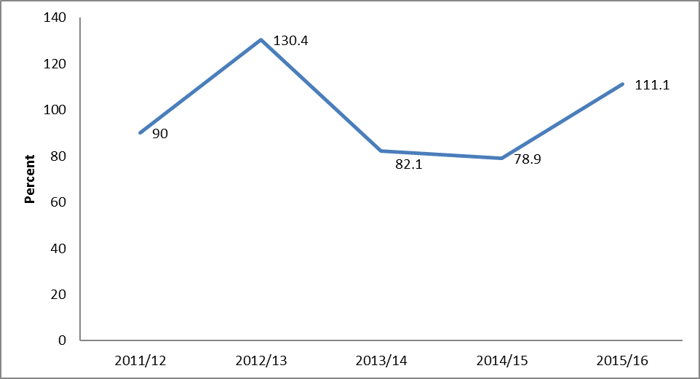
Source: MICAS 2016

Conclusion and Recommendations
The information contained in this report provides important data under four Sectors under the Ministry which are Information, Culture, Arts and Sports. However, it needs the inclusion of other data which are still being processed under the Ministry of Information, Culture, Arts and Sports. The delay was due to validation of the reliability and quality of data available.

This is the second report in a series of statistical reports of the Ministry. It thus calls for more work to be undertaken in the future. Therefore, there is still a need to reveal missing data observed in the process of developing this report. Some of these data gaps are as follows:-
- List of Social media blogs owners and bloggers;
- Trends of frequently (daily, weekly, monthly etc published newspapers/magazines);
- Foreign Media Houses in Tanzania;
- List of Cultural heritage resources and books related to cultural issues;
- Number of cultural, sports and Information officers in Tanzania Mainland;
- Number of language spoken and existing in Tanzania Mainland;
- Film Infrastructure including Video Exhibition Centers (VEC) known as “Vibanda Umiza”, Video Libraries, Studios and Cinema Halls;
- Film Practitioners including distributers, producers, directors, actors and script writers;
- Participation in games, sports and physical activities;
- Sports infrastructures e.g cricket grounds, tennis courts;
- Student enrollment and graduates from Malya College of Sports Development by field of study.

